PSYCHOLOGICAL DIMENSIONS OF ENGLISH-SPEAKING ANXIETY: A SYSTEMATIC REVIEW OF CAUSES, EFFECTS, AND COPING STRATEGIES IN HIGHER EDUCATION
Ben Dan Tan ¹, *Noraini Said², Nur Suhaidah Sukor³

^{1,2,3}Faculty of Education and Sport Studies, Universiti Malaysia Sabah, Malaysia

Corresponding email: noraini.said@ums.edu.my
Abstract: In today's globalized world, English language competency is essential not only for academic purposes but also for international interactions. However, many Higher Education English Language Learners (HE-ELLs) experience English-speaking anxiety, which negatively affects their classroom performance and learning outcomes. There is a relatively fragmented body of literature currently available regarding English-speaking anxiety among HE-ELLs. Therefore, grounded in psychological theories of language anxiety, this study comprehensively and methodically synthesizes 24 recent empirical studies to summarize the characteristics of research on English-speaking anxiety among HE-ELLs and identify research trends. Following the Preferred Reporting Items for Systematic Reviews and Meta-Analyses (PRISMA) guidelines, relevant studies published in the last five years were collected from Scopus, ProQuest Education, ERIC databases, and further augmented by Google Scholar. In the final screening, 24 articles were included for analysis. The findings reveal that psychology-related factors, language-related factors, performance-related factors, and socio-cultural factors are all associated with English-speaking anxiety among HE-ELLs. These factors may impact learners' classroom performance, language learning outcomes, and mental health. To relieve English-speaking anxiety, various teaching strategies have been proposed, including the application of virtual reality technology, group cooperative learning, and increasing opportunities for interaction with native speakers. The findings of this study provide a deeper understanding of English-speaking anxiety among HE-ELLs in English learning in recent years. By thoroughly analyzing the root causes of English-speaking anxiety and implementing effective strategies, it offers valuable references for educators, researchers, and policymakers in overcoming anxiety in English-speaking communication.
Keywords: Higher education English language learners, English-speaking anxiety, systematic review, educational psychology

INTRODUCTION
Along with the evolution in language acquisition theory, researchers tend to think that language learning is a complicated procedure that combines both cognitive and emotional aspects. Since the 1980s, researchers have consistently highlighted the influence of affective variables upon English learning and especially how anxiety plays an important part in English-speaking development among Higher Education English Language Learners (HE-ELLs). Several studies have demonstrated that speaking anxiety may negatively affect the language learning or speaking performances (Alazeer & Ahmed, 2023; Helvira et al., 2025). Anxiety, apprehension, and low self-confidence among HE-ELLs in using English as a medium of spoken communication may evolve to long-term psychological distress, hindering them from fully participating in communicative activity, finally affecting the improvement of speaking skill (Liu & Shi, 2023; Wijaya, 2023). English-speaking communication needs a high level of interaction from HE-ELLs, so English-speaking skill is considered as one of the skills which could make learners more anxious in the learning processes (Rajitha & Alamelu, 2020; Paraguas, 2025). From a psychological perspective, speaking anxiety is closely linked to constructs such as communication apprehension, fear of negative evaluation, and self-efficacy (Horwitz et al., 1986). Understanding and alleviating such anxiety is now the topic of concern among instructors and scholars. The recent literature review about English learners' speaking anxiety has presented a summary of current tendencies and studies conducted in that area, indicating its present state of evolution.
Numerous studies have been conducted repeatedly on English speaking anxiety with a purpose of enhancing the impact of English language learning. Prominent among these are the recent efforts of Rajendran et al. (2025), Tania et al. (2025), and Choi (2025). Rajendran et al. (2025) conducted a comprehensive narrative review on English-speaking anxiety. Their article analyzed the main causes and coping strategies of speaking anxiety among HE-ELLs, expanding our knowledge about this sector on a larger scale. However, they did not provide detailed information on the time range of literature search and database source as well as inclusion/exclusion criteria, which somewhat restricted it from reflecting current trends of empirical work. Tania et al. (2025) conducted an analysis of the literature on English speaking anxiety from 2018 to 2024. Their study found that the factors that trigger speaking anxiety among HE-ELLs mainly stem from the fear of negative evaluations, language deficiencies and classroom dynamics. All these reasons lead to lack of motivation for speaking, presentation and hesitation during the interaction with others. Also, they mentioned AI and multi-modal approaches to learn as a way for reducing speaking anxiety. Their study extended the conversation about why people are anxious and how to reduce it and offered good examples of how to build inclusive English classrooms and stress-free classroom environments. However, their research mainly consists of descriptive summaries focusing on the anxiety triggers in classroom settings. The comprehensive comparison and evaluation among different research results remains relatively limited.
Choi (2025) carried out a literature review by analyzing eleven empirical studies about speaking anxiety with the English Language. Choi explored how VR has had potentials as well as difficulties for alleviating student's speaking anxiety from 2018 onwards. It was found that through situation-based VR, learners can have higher motivation to learn languages while decreasing their speaking anxiety. However, different designs and implementation environments greatly influence the VR intervention's efficacy and measuring instruments. Future research needs to further adopt more rigorous experimental designs and long-term follow-up evaluations. Moreover, his review mainly focuses on the specific technical path of virtual reality, lacking a systematic integration and analysis of the overall causes, impacts and diverse coping strategies of English-speaking anxiety.
According to the literature review, the current research still has a relatively scattered research perspective and lacks an integrated research framework for understanding English-speaking anxiety among HE-ELLs. Previous studies mostly focused on a single aspect, such as mainly paying attention to the anxiety-triggering factors in classroom situations. Some studies focused more on macroscopic descriptions or concentrated on specific intervention paths such as virtual reality, resulting in the fragmented characteristics of the existing research findings. Moreover, research methods and measurement tools used to investigate English-speaking anxiety among HE-ELLs vary considerably and currently there is a lack of consistent methods to compare and integrate these research conclusions.
The aforementioned research limitations have restricted our comprehensive exploration of the causes, impacts and coping strategies of HE-ELLs' English-speaking anxiety. It is necessary to conduct a systematic review of the empirical studies in recent years to integrate them thoroughly and gain a deeper understanding of the causes, impacts and coping strategies associated with English-speaking anxiety among HE-ELLs.
Hence, this paper carried out an overview with focus on the English-speaking anxiety from the empirical studies for the last five years and rigorously analyzed its causes, effects and solutions of English-speaking anxiety. It systematically introduced the current research development on this topic. This paper also comprehensively summarized the research methodology, synthesized core conclusions and suggested a combined research model in order to better understand the phenomenon of English-speaking anxiety. The present literature review can provide some theoretical reference for further studies and pedagogy.
For the purpose of this review, the term 'Higher Education English Language Learners' (HE-ELLs) is utilized universally to encompass university learners studying English as a Second Language (ESL) and English as a Foreign Language (EFL), except where distinct context dictates otherwise. This terminology is adopted to ensure consistency and avoid ambiguity across the reviewed literature.
This paper posed the following fundamental research question: based on the selected empirical studies, what are the characteristics of research on English-speaking anxiety among HE-ELLs in terms of causes, effects and coping strategies?
In addition, from a psychological perspective, this paper further asks: how can the identified causes, effects, and coping strategies of English-speaking anxiety be understood within established psychological frameworks, and what implications do they have for theory development and pedagogical practice?

METHODOLOGY

Research Design
The present research adopted the systematic literature review method. Its main idea is that in response to a particular research question, use a standardised approach for screening, integrating and evaluating the literature and report findings based on the available evidence (Xiao & Watson, 2019). The present research chose journal articles that were about speaking anxiety among HE-ELLs in both ESL and EFL and analysed the selected literature according to the research question. This research adhered to the Preferred Reporting Items for Systematic reviews and Meta-Analysis (PRISMA) statement (Moher et al., 2009). PRISMA is a collection of evidence-based recommendations that guide authors in preparing and reporting any type of SRs or MAs (Nash, 2025). Not only does it help authors to write better reports but it can be used by review readers/editors as well for thorough evaluation of published SRs (Mishra & Mishra, 2023). The completed PRISMA checklist is appended as supplementary material in Appendix 1.

Based on this, the review process in this paper included identification, screening, eligibility assessment, and final inclusion of relevant studies. All retrieved records were screened according to predefined inclusion and exclusion criteria to ensure consistency and transparency throughout the review process.

Data Resources
To select high quality literature for inclusion in this review, this paper chose Scopus, ProQuest Education/ERIC databases as the main source to search literature. We also used Google Scholar to augment our core searches on curated databases. We adopted an exhaustive but impartial approach toward performing systematic literature screening process. In line with recommendations by Bramer et al. (2017) for comprehensive literature retrieval in systematic reviews, the selection of multiple databases was adopted to ensure broad and complementary coverage of the research domain. Scopus was included due to its extensive multidisciplinary indexing and strong coverage of internationally renowned journals in applied linguistics, language education, and social sciences. ERIC and ProQuest Education were selected because they specifically focus on educational research, including language learning, classroom practice, and learner psychology, which are highly relevant to speaking anxiety research. Google Scholar was employed to increase the capture of local peer-reviewed studies. The combination of these databases was intended to maximize retrieval of relevant studies while minimizing the risk of database-specific omission and publication bias.

The search string used in this research was 'ESL speaking anxiety' or 'English-speaking anxiety' or ‘EFL speaking anxiety’. These terms were combined using Boolean operators as follows: "English-speaking anxiety" OR "ESL speaking anxiety" OR “EFL speaking anxiety” AND "causes" OR "coping strategies". The literature search covered studies published between January 1, 2021, and December 31, 2025. To obtain and filter high-quality literature in this study, keywords matching the search terms in the title or abstract were taken into consideration. Moreover, to guarantee the comprehensiveness of the review and decrease the possibility of publishing bias, we searched additional literature in this research, extended the search range with the latest 100 documents of the Google Scholar database and performed additional citation retrieval via Scopus for the identification of highly cited documents.

To ensure academic validity, the indexing and peer-reviewed status of all papers published online in 2025 were manually verified via Scopus and official journal metadata registries prior to final inclusion. Only studies with confirmed publication records and accessible full texts were retained in the review. This procedure ensured the academic legitimacy and reliability of recently published literature.
Inclusion and Exclusion
To maximize the research findings, this study applied five inclusion criteria: (1) the research should be an empirical study and it has been published for no more than five years according to the general design of this review; (2) the research theme should focus on ESL or EFL speaking anxiety or English-speaking anxiety and the research should be written in English language; (3) the participant of the study is learner-centered and article-type paper is preferred; (4) open access or refereed publications are preferred; (5) subject areas include social sciences, humanities and arts, psychology and education. Also, in order to exclude those literature which are outside the scope of this study, four exclusion criteria were used: (1) the topic is unrelated with learners' speaking anxiety; (2) language is non-English; (3) non-empirical studies without empirical data; (4) duplicate literature or literature where the full text is not available.

Search Result Screening
The screening process was conducted by the researchers using predefined inclusion and exclusion criteria. To ensure consistency in study selection, all records were screened following the same protocol throughout the review process. To establish inter-rater reliability, researchers independently screened 20% (n = 43) of all retrieved records. Cohen's kappa was κ = 0.70, indicating substantial agreement (Landis & Koch, 1977), and all discrepancies were resolved through discussion.

During the first round of keyword search, we identified 48 articles in the Scopus database and 166 articles in the ProQuest Education/ERIC database. Next, we screened the searched results from 'Screened Results' part of each database one by one according to the defined inclusion criteria and finally selected 10 and 25 pertinent documents from the Scopus database and the ProQuest Education + ERIC database respectively. Furthermore, in addition to using database searching results, relevant papers were also collected from Google Scholar and supplementary citation-based search via Scopus, and finally selected 7 and 3 articles as other sources to be screened in later analysis process.

Then, we screened the title and abstract in order to find out if the literature meets the research standards or not; finally 26 related articles were retained. Afterwards, we performed secondary screening to exclude those articles out of research scope and finally selected 24 articles into our review. Figure 1 displayed the literature screening procedure of this systematic review.

Figure 1: Flowchart of Screening Process
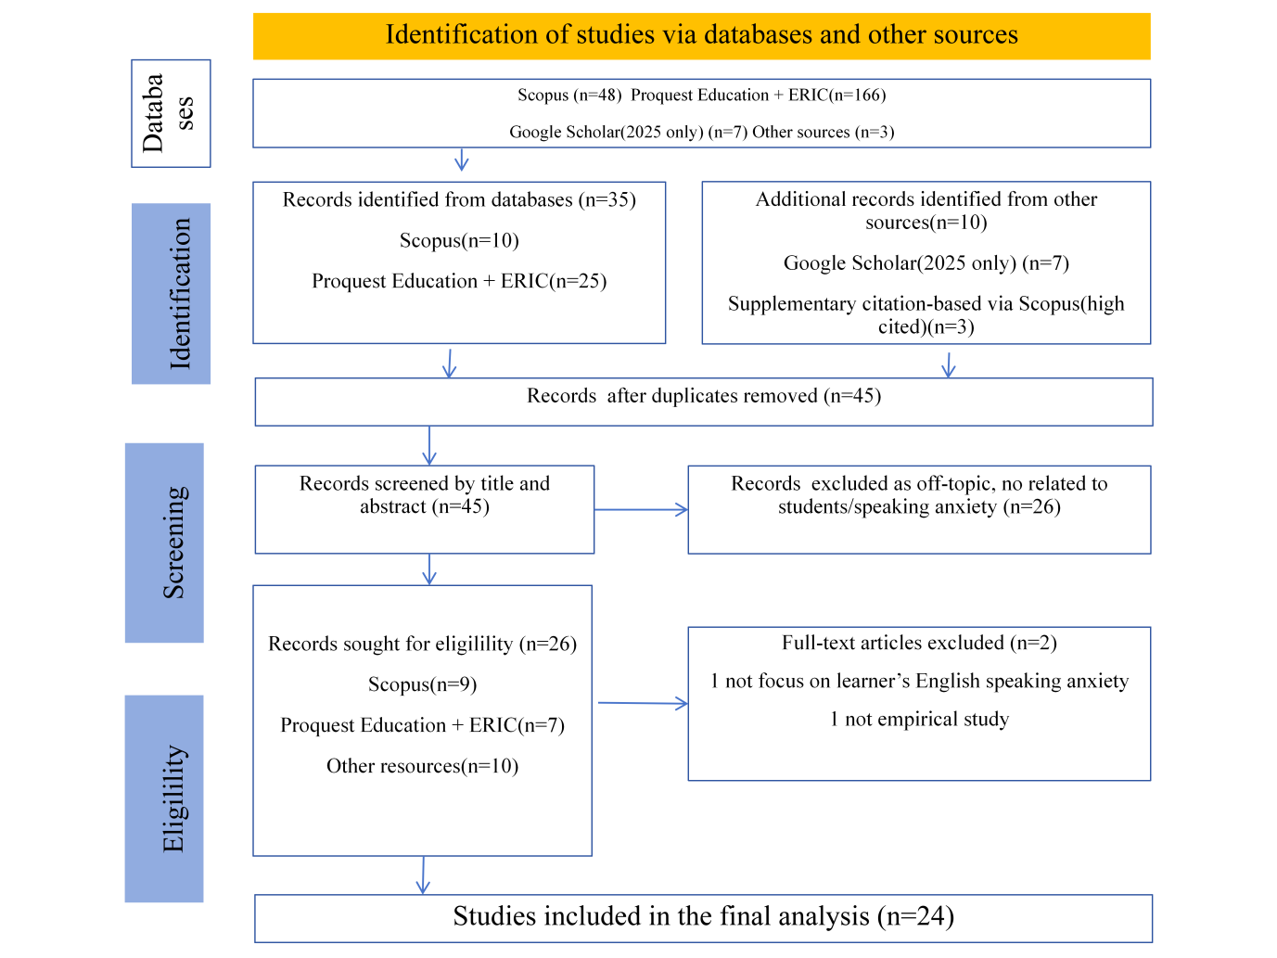

Quality Appraisal
Methodological quality was evaluated using the Mixed Methods Appraisal Tool (MMAT; Hong et al., 2018). Each included study was assessed according to five design-specific criteria relevant to its research design. Studies meeting four or more criteria were deemed to have satisfactory methodological quality and were retained for synthesis.

Data Analysis
Six categories were used in this study to address the main research questions: researcher name, country, participants, research method, measurement instruments and findings. Accordingly, the coding technique of thematic analysis was used for grouping and summarizing findings, with a special emphasis on causes of English-speaking anxiety, the effect of anxiety on learners, and coping strategies for reducing anxiety.

RESULTS
The quality appraisal indicated that the majority of the included studies were of moderate to high methodological quality. Most studies satisfied at least four MMAT criteria, particularly in terms of clear research questions, appropriate data collection methods, and coherent interpretation of findings. This suggests that the evidence base synthesized in this review is methodologically reliable.

Table 1 systematically reviewed the 24 empirical studies included in this research regarding English anxiety. Based on the content of this table, this research elaborated on the conclusions of this review from several aspects: the basic characteristics of the studies, the causes of English-speaking anxiety, the effects of English-speaking anxiety, and the coping strategies for English-speaking anxiety.

Table 1: Summary of Reviewed Empirical Studies on English-speaking Anxiety

Author (s) & year | Country | Participants | Method | Instrument | Causes | Effects | Coping Strategies
Ballıdağ & Aydın (2025) | Turkey | University preparatory learners | Experimental | Speaking anxiety scale | Oral performance pressure; Real-time interaction anxiety | Reduced desire for speaking | AI chatbots; peer interaction
Xiong et al. (2025) | USA | EAL counseling trainees | Qualitative | Interviews | Identity pressure; Language proficiency insecurity | Persistent anxiety in academic and training settings | Peer and mentor support; self-reflection and emotion regulation strategies
Alhasan et al. (2024) | Jordan | Undergraduates | Qualitative | Interviews | Fear of negative evaluations; Lack of self-confidence | Avoidance | Peer encouragement and supportive interactions
Almotiary (2022) | Saudi Arabia /USA | Adult ESL learners | Qualitative | Interviews | Cultural background differences; Fear of making mistakes; Language identity anxiety | Increased English-speaking anxiety | Not examined
Badrasawi et al. (2021) | Malaysia | Science & technology undergraduates | Quantitative | Speaking anxiety scale | Lack of self-confidence; Low self-perception ability | High level of English-speaking anxiety | Realistic situations for practice; training modules for instructors
Bai & Xian (2024) | China | University learners | Quantitative | Anxiety & self-regulation scales | Examination-oriented pressure; task difficulty | Performance fluctuation | Digital story-telling activity
Banani (2025) | Iraq & Yemen | College learners | Mixed methods | Speaking anxiety questionnaire | Insufficient language skills; fear of judgment | Increased anxiety | AI-assisted learning methods
Bensalem (2021) | Tunisia | EFL learners | Quantitative | Anxiety scale; enjoyment scale | Classroom anxiety atmosphere; negative emotional experience | Decreased in communication willingness | Positive learning environment
Ch’ng et al. (2025a) | Malaysia | ESL undergraduates | Quantitative | PSCAS (enhanced) | Public speaking situational stress; self-awareness | Increased public speaking anxiety | Not examined
Ch’ng et al. (2025b) | Malaysia | ESL undergraduates | Quantitative | Public speaking anxiety questionnaire | Task difficulty; insufficient language proficiency | Increased anxiety levels in academic presentation situations | Not examined
Author (s) & year | Country | Participants | Method | Instrument | Causes | Effects | Coping Strategies
Fenyi et al. (2023) | Ghana | English-major tertiary learners | Quantitative | Speaking anxiety questionnaire | Feelings of inferiority; fear of making mistakes; lack of spontaneity and insufficient preparation; fear of negative evaluations from teachers and classmates; limited language knowledge and vocabulary; self-criticism. | High speaking anxiety | Creating a learner-friendly, less formal classroom environment; peer assessment
Gu (2025) | China | Chinese ESL learners | Quantitative (SEM) | FLCAS; confidence scale | Lack of confidence in communication; Low speaking proficiency | Increased speaking anxiety; impaired communication | Virtual reality scenarios
Irulappan (2025) | India | ESL university learners | Quasi-experimental | FLCAS; oral tests | Negative evaluation anxiety; communication fear; lack of confidence | Reduced fluency and accuracy | Speaking communication strategies and structured training
Khalaf & Omara (2022) | Egypt | University learners | Quantitative | ELAS | Gender-related emotional differences; Test item deviations | Differences in anxiety measurement | Not examined
Luo & Xiong (2025) | China | EFL university learners | Quantitative | Anxiety; motivation scales | Academic pressure; Emotional factors | Mixed learning motivation effects | Not examined
Meihua (2021) | China | Postgraduate learners | Experimental | Speaking anxiety scale | Presentation pressure; high academic expression requirements | Speaking anxiety significantly decreased. | Not examined
Nadeem et al. (2025) | Pakistan | University ESL learners | Experimental | Speaking anxiety scale | Lack of practice; lack of confidence; fear of making mistakes in public | Avoiding oral activities; Decrease in classroom participation | AI-assisted tools to conduct repeated oral practice
Namsaeng & Thuratham (2025) | Thailand | Undergraduates | Quantitative | Speaking anxiety scale; vocabulary test | Insufficient vocabulary; Limited language resources | Lower speaking performance. | Not reported
Ozturk et al. (2022) | Turkey | University Learners | Quantitative (SEM) | Skill-based anxiety scales | Skill-related anxiety | Increased overall anxiety | Not examined
Pai et al. (2024) | Taiwan | University learners | Experimental | Anxiety questionnaire | Course task pressure; High speaking requirements | Increased learners' anxiety | Game-based teaching strategies
Pysarchyk et al. (2025) | Ukraine | ESL university learners | Qualitative | Interviews | Fear of making mistakes, negative evaluations from classmates; psychological pressure in class | Reduced learners' willingness to speak in class; avoidance of impromptu expressions. | Teacher's emotional support; positive classroom atmosphere
Quvanch et al. (2024) | Afghanistan | EFL undergraduates | Quantitative | Speaking anxiety scale | Fear of making mistakes; fear of negative feedback; insufficient proficiency | Avoided English-speaking communication | Self-regulation learning methods; emotional management strategies
Sapuan et al. (2025) | Malaysia | University ESL learners | Quantitative | Speaking anxiety questionnaire | Insufficient vocabulary and grammar knowledge; evaluation pressure | Reduced learners' speaking confidence | Student self-practice; peer support
Yağcıoğlu & Çalışkan (2024) | Turkey | Primary school learners | Experimental | Listening & speaking anxiety scales | Task difficulty; high-tension classroom activities | Increase listening and speaking anxiety | Game-based learning

CHARACTERISTICS OF THE RESEARCH ON ENGLISH-SPEAKING ANXIETY
As shown in Figure 2, it can be seen that there was a growing trend in the number of published studies from year 2021 until 2025, especially a steep rise from 2024 to 2025. It indicates that as an affective variable in second language acquisition, English-speaking anxiety is still attracting researchers' attention (Horwitz et al., 1986; MacIntyre & Gregersen, 2012).
Figure 2: Distribution of Studies by Year
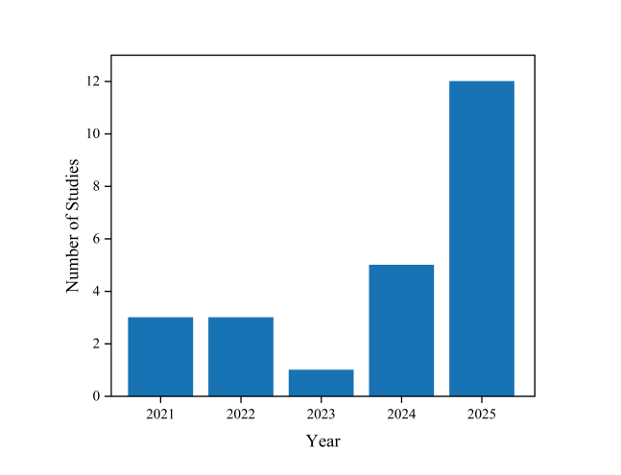
Figure 3 showed that the empirical studies included in this study covered different countries such as China, Iran, Saudi Arabia and Malaysia. These data indicate that the articles from Malaysia and China are the most numerous, suggesting that these regions have a high level of concern regarding learners' English-speaking proficiency and anxiety issues. This geographic concentration should be explicitly acknowledged, as it makes the findings particularly relevant and applicable to the educational and psychological context of Southeast Asia.
Figure 3: Distribution of Studies by Country
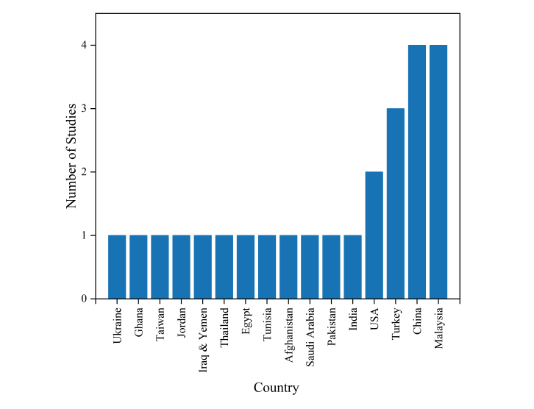
In terms of education level, more than 90% of the research subjects were found to be learning at a higher level of education as illustrated in Figure 4. During these studies, the number of lower-level learners was quite small, being no more than 5%, which indicated that most studies in the last five years were performed with HE-ELL learners. It highlights the necessity of paying attention to English-speaking anxiety in higher education.
Figure 4: Participants by Education Level
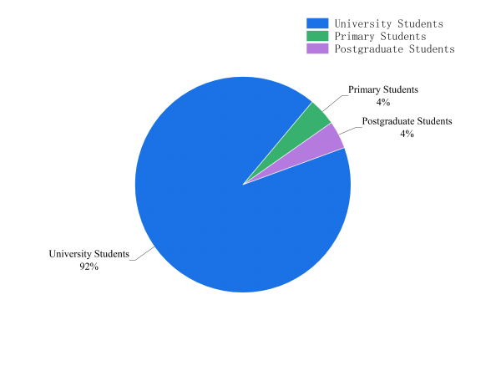
In terms of research method, among the 24 selected articles, quantitative research accounted for more than half, while mixed-method research was relatively scarce, with only one article. Additionally, qualitative research and experimental research accounted for 4 and 6 articles respectively (Figure 5), which highlights a limitation in capturing learners’ subjective experiences.
Figure 5: Distribution of Studies by Research Method
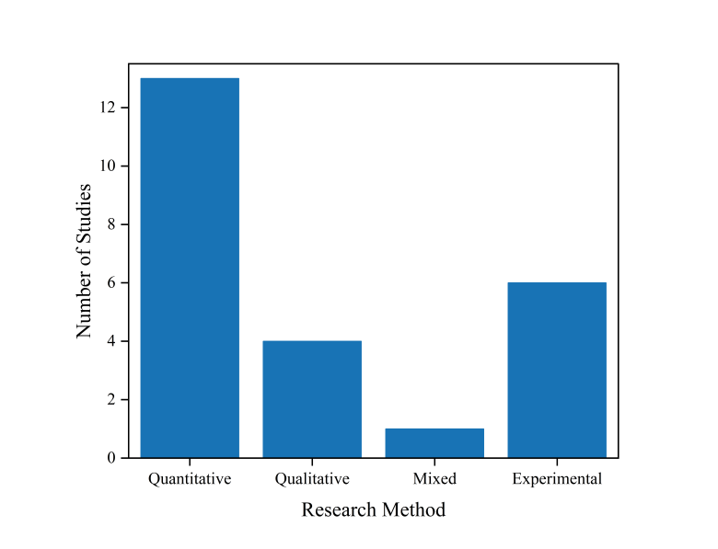
CAUSES OF ENGLISH-SPEAKING ANXIETY
This study provides a summary of the causes for the English-speaking anxiety based on the analysis of these 24 studies. These studies unanimously indicate that HE-ELLs generally experience English-speaking anxiety. For instance, they are afraid of making mistakes, worried about being criticized, and feel uncomfortable when communicating with native speakers. The causes of this anxiety involve multiple dimensions, including the HE-ELLs’ psychological state, language proficiency, task and performance-related factors, classroom and social-cultural factors.
The Psychological Factors of Learners
Several investigations claimed that fear of negative evaluation was one of the main factors causing learners' anxiety during their English-speaking communication (Quvanch et al., 2024; Pysarchyk et al., 2025; Irulappan, 2025; Sapuan et al., 2025). Learners often experience speaking anxiety due to the possibility of receiving negative feedback from peers, which leads them to be reluctant to speak in class (Fenyi et al., 2023; Alhasan et al., 2024; Banani, 2025).
Based on the theory of social anxiety, the fear of negative evaluations is regarded as the core sensitivity of individuals to others' evaluations in social interactions (Leary, 1983). When learners are highly sensitive to others' negative evaluations, their social anxiety will intensify, which will inhibit HE-ELLs' participation in classroom speaking activities. This psychological trait can be measured using the Fear of Negative Evaluation Scale proposed by Watson & Friend (1969).
Another psychology-related factor close to the fear of negative assessment is the HE-ELLs’ fear of making mistakes. Among them, the fear of making any grammatical, lexical or pronunciation mistakes is the major cause for inducing learner's anxiety while communicating through speaking mode, as many learners over-emphasize their utterances with a great deal of attention towards grammar correctness and correct pronunciation, and this perfectionism leads to significant psychological stress (Pysarchyk et al., 2025; Nadeem et al., 2025). So, the fear of making mistakes is one of the biggest barriers that prevent learners from participating in class discussions and greatly affects learners’ confidence for speaking (Fenyi et al., 2023).
Learners may also feel anxiety when presenting their ideas by using English language due to lack of self-confidence (Badrasawi et al., 2021; Irulappan, 2025; Nadeem et al., 2025). Their discomfort with their language proficiency may also make them feel uneasy about themselves while speaking English (Xiong et al., 2025). Such a negative attitude may increase learners' psychological load and cause them to experience speaking anxiety (Gu, 2025). Meanwhile, such mentality could result in a vicious circle, while recurrent anxiety might also hinder their learning process and further undermine learners' confidence (Horwitz, Horwitz & Cope, 1986).
Factors of Learners' Language Proficiency
The literature review reveals that poor language competence of the learners has been identified as one of the causes of learner's apprehension when it comes to English-speaking communication, which is reflected in the low level of English language competence of the learners, a lack of sufficient language input or practice opportunities. For example, if the learner does not know enough words due to low level of grammar knowledge and difficulties with pronunciation while speaking in the English language, they tend to experience speaking anxiety (Ch'ng et al., 2025b; Sapuan et al., 2025; Gu, 2025). When they are unable to rapidly find suitable words for them to express themselves more accurately, they will be nervous from within and hesitate or even avoid speaking (Namsaeng & Thuratham, 2025; Fenyi et al., 2023).
In addition, long-term lack of real speaking practice and rare exposure to the English native environment will make it hard for learners to speak English fluently, which also restricts the improvement of their language proficiency (Quvanch et al., 2024; Nadeem et al., 2025). Hence, lack of language proficiency and insufficient practice are the major internal causes for learners' anxiety towards speaking communication.
Task and Performance-Related Factors
Another aspect affecting learners' English-speaking anxiety is task and performance-related factors. It has been found that if learners over-focus on their own performance and outcome of their public speaking, they might become nervous in the formal situations such as speaking or presenting orally at the class (Ballıdağ & Aydın, 2025; Bai & Xian, 2024). In interactive communication that requires immediate responses, the pressure of real-time language processing can easily magnify learners' concerns about the accuracy of vocabulary retrieval and expression, thereby triggering communication anxiety and avoidance behaviors (Namsaeng & Thuratham, 2025; Fenyi et al., 2023).
Furthermore, when the oral task itself is of a higher difficulty level, requires complex expressions to be completed within a limited time, or involves content with strong academic nature, learners are more likely to experience anxiety due to insufficient preparation or a mismatch between their abilities and the task requirements (Quvanch et al., 2024; Sapuan et al., 2025). In an examination-oriented classroom situation, speaking performance is directly associated with academic performance and therefore intensifies the apprehensions of learners concerning the implications of failure, making them more anxious in performing the tasks (Bai & Xian, 2024).
Hence, the kind of task, the context and the pressure collectively constitute a crucial factor which is called situational aspect, influencing English-speaking anxiety. This finding can be explained by Spielberger's (1983) state-trait anxiety theory. The state anxiety induced by the task situation will significantly enhance in high-pressure oral tasks, thereby further inhibiting learners' language performance.
Classroom and Social-Cultural Factors
The classroom environment and teaching method of teachers affect learners' English-speaking anxiety significantly (Rajendran et al., 2025). If teachers use too rigorous teaching approaches, set up too tough home assignments or give learners a lesson of correction and punishment directly in class, it will greatly damage student's confidence (Pai et al., 2024; Yağcıoğlu & Çalışkan, 2024; Pysarchyk et al., 2025). The speaking examinations would exacerbate the anxiety of learners during the exam period and place immense pressure on them, which may subsequently further magnify anxiety in speaking expression. Bai and Xian (2024) clearly pointed out that HE-ELLs were extremely worried about making mistakes in speaking examinations, leading to heightened fear and anxiety during speaking tests.
In one particular social and cultural setting, the difference between each student's level of speaking anxiety in English is considerable. As an example, learners coming out of single-sex education systems, such as in Saudi Arabia for girls, find it very difficult to be in a mixed classroom setting (Almotiary, 2022). The other factors include the pressure of language identity or career expectation that are also considered to be the causes for learners' English-speaking anxiety. The learners with aspirations for reaching target levels of English ability or those facing more challenging admission criteria are likely to feel added pressure (Rajendran et al., 2025). So it can be seen that classroom environment along with university's examination system and society's culture are all part of the external environment which leads to student's anxiety while speaking English.
While there is agreement among scholars about the main determinants of English-speaking anxiety, certain investigations looked into other learner-specific factors that may contribute to speaking anxiety. For example, Sapuan et al. (2025) conducted a study with ESL learners in Malaysia; the results revealed that no significant difference was observed between genders' anxiety level for most important factors including speaking apprehension and fear of negative evaluation.
As one of the causes of learners' English-speaking apprehension stated in the preceding paragraph, particularly their fear of evaluation and low self-confidence are very consistent with the traditional theories like Krashen's Affective Filter Hypothesis and Foreign Language Anxiety theory. Foreign language anxiety is regarded as a specific type of situational anxiety. The dimensions it encompasses, such as communication anxiety, exam anxiety, and fear of negative evaluations, directly affect a learner's language performance through emotional and cognitive mechanisms.
Furthermore, these variables that influence the learner's English-speaking anxiety are not independent of each other but intertwined together as an effective anxiety cycle mechanism. The Willingness to Communicate model proposed by MacIntyre et al. (1998) further indicates that higher levels of anxiety significantly reduce learners' willingness to engage in speaking communication, thereby limiting their language output and actual performance. So, speaking anxiety does not only weaken the learning enthusiasm of learners but also affects the improvement of learners' English ability.
THE EFFECTS OF ENGLISH-SPEAKING ANXIETY
The results of the studies revealed that English-speaking anxiety among HE-ELLs may be detrimental to learners’ performance in class speaking, language acquisition and emotional health. In particular, a number of studies found that high levels of speaking anxiety could decrease the HE-ELLs' willingness to speak, leading them to avoid any speaking activities and impromptu expressions. For example, they do not want to speak and express themselves in class when learning the English language (Pysarchyk et al., 2025) and decrease their participation in speaking communication (Quvanch et al., 2024; Alhasan et al., 2024) or exhibit a decline in communication willingness (Ballıdağ & Aydın, 2025; Bensalem, 2021).
Regarding the English-speaking skill, studies have repeatedly found that speaking anxiety negatively affects HE-ELLs' English expressiveness with regard to both fluency and accuracy (Irulappan, 2025), thereby weakening their language speaking skills (Gu, 2025). Among them, learners with high levels of anxiety exhibit more prominent speaking ability issues in oral tasks than those with low anxiety levels (Namsaeng & Thuratham, 2025). In addition, various degrees of anxiety will also impact on the learner's language output (Bai & Xian, 2024). For instance, under some particular circumstances such as in public speaking (Ch'ng et al., 2025a), academic presentations (Ch'ng et al., 2025b) and academic-training environments (Xiong et al., 2025), the learners' level of speaking anxiety will dramatically rise, which only compounds the difficulty they already have expressing themselves in English.
From the perspective of the impact on HE-ELLs' mental health, long-term anxiety may lead to a decline in learners' self-esteem in learning languages, a reduction in their motivation to learn, and a cessation of learning. Even this persistent anxiety may cause a sense of helplessness, leading to emotional depression and even depression, thereby affecting the overall emotional health of learners(Shami et al., 2025).
Multiple studies have shown that English-speaking anxiety is widespread among learners (Fenyi et al., 2023; Banani, 2025; Pai et al., 2024; Yağcıoğlu & Çalışkan, 2024). Emotionally and psychologically, speaking anxiety is likely to lower learners' self-confidence when they express themselves (Sapuan et al., 2025) and exacerbates their negative feelings in class (Almotiary, 2022; Ozturk et al., 2022; Badrasawi et al., 2021), thus creating some mental boundaries that hinder them from expressing themselves. Furthermore, there are also some research on gender difference on English-speaking anxiety (Khalaf & Omara, 2022); the findings show that learners' English-speaking anxiety will be moderated by gender.
But the evidence is mixed. Despite the fact that the majority of research has focused on the adverse effect of English-speaking anxiety, there are still few studies that have examined its positive perspective on English-speaking anxiety. As Luo & Xiong (2025) suggested, in some circumstances a certain degree of anxiety could promote the learning willingness of the learners and would help improve their English performance. According to Meihua (2021), the application of teaching activity like TED speech is proved to have a significant impact on reducing student's speaking anxiety level. It indicates that speaking anxiety could be adjustable at least to some extent.
This phenomenon can be explained by the concepts of facilitative and debilitative anxiety in psychology. Alpert & Haber (1960) hold that facilitative anxiety can effectively motivate learners to learn a language, while debilitative anxiety will further hinder learners' learning process and reduce learning outcomes. Thus, it indicates that English-speaking anxiety does not necessarily have a negative impact on learners, but rather depends on the level of learners' anxiety and the specific learning situation.
STRATEGIES AND TEACHING INTERVENTIONS FOR OVERCOMING ENGLISH-SPEAKING ANXIETY
To reduce excessive English-speaking anxiety, some researchers have proposed specific methods to alleviate this anxiety from various perspectives. For instance, HE-ELLs can engage in self-regulation and pre-class preparation, teachers can create a supportive classroom environment, educational institutions can improve course design and implement technological assistance and digital interventions.
According to the research, English language learners could deal with their fear of speaking by self-regulation and strategy training. By systematic structure practice, HE-ELLs can slowly build up the courage to speak out so as to decrease the level of speaking anxiety (Irulappan, 2025). Preparation for class, self-study abilities and emotional control skills are all found effective at alleviating HE-ELLs' anxiety about using the target language for communication purposes (Quvanch et al., 2024). In academic and professional training contexts, integrating mentor support, self-reflection and emotion regulation strategies can effectively enhance learners' adaptability and self-confidence (Xiong et al., 2025). These strategies can enhance learners' sense of perceived control and reduce their threat evaluation in uncertain language situations, thereby alleviating anxiety responses. This is in line with the core concept of the Control-Value Theory.
Findings from this review suggest that researchers acknowledge and agree on the facilitative effect of a facilitating class climate for HE-ELLs' reduction of their English-peaking anxiety, as evidenced by studies indicating teachers' affective support or a conducive class climate is an important factor to mitigate speaking anxiety. For example, if teachers give encouraging language and positive feedback and try to create a safe classroom environment for learners to express themselves, then the learners' anxiety towards making errors and their worries over being negatively evaluated will be considerably reduced (Pysarchyk et al., 2025). Peer support and interactions in class has also shown to be effective at reducing learners' anxiety of being negatively evaluated while increasing their tendency to communicate (Alhasan et al., 2024; Sapuan et al., 2025). From a psychological perspective, this supportive classroom environment reduces the core source of anxiety, namely "social evaluative threat", thereby enabling learners to fundamentally alleviate their emotional stress and stop overly focusing on negative evaluations. As a result, learners can engage in expression more actively and smoothly.
The findings of this literature review also indicate that optimization of the university English curriculum system and methods can be done by incorporating game teaching methods into classrooms. It can be helpful for reducing student's academic pressure, increasing participation, and alleviating their communication anxiety in English (Pai et al., 2024; Yağcıoğlu & Çalışkan, 2024). This is also in line with the control-value theory, which holds that game teaching enhances the interest and value of learning tasks, while increasing the learners' sense of control and participation, thereby reducing anxiety levels. Furthermore, some studies suggest providing learners with more opportunities for speaking practice in real-life contexts, offering relevant training modules for teachers and optimizing language policies and course programs at the higher education level to systematically support the emotional development of learners (Badrasawi et al., 2021).
Because English-speaking anxiety is a long-term phenomenon, in recent years more and more researchers are concerned with the positive effect of artificial intelligence on reducing learners' English-speaking anxiety. Research has shown that learners can gradually build up their confidence and reduce anxiety when giving public speeches by repeatedly practicing in a low-stress environment using AI-assisted tools (Nadeem et al., 2025; Banani, 2025).
For example, Virtual reality (VR) provides a simulated immersive environment where learners can practice their speaking skills in various real-life situations, effectively alleviating their nervousness and anxiety about being judged (Ballıdağ and Aydın, 2025). Psychologically, this is mainly because VR, to a certain extent, weakens the social evaluation context in real interpersonal interactions, thereby reducing learners' perceived threat of negative evaluations. Furthermore, the task of creating digital stories has been proven to effectively promote learners' autonomy and sense of control, thereby reducing their English-speaking anxiety both cognitively and emotionally (Bai & Xian, 2024).
Overall, existing research indicates that English-speaking anxiety among HE-ELLs is somewhat modifiable. By creating a supportive classroom environment, integrating digital technology, enhancing HE-ELLs' self-regulation abilities and optimizing course and institutional design, anxiety can be effectively alleviated at various levels. However, some studies still focus mainly on anxiety measurement and lack in-depth exploration of intervention mechanisms. Future research should further strengthen systematic verification of the effectiveness of strategy implementation and its long-term impact.
DISCUSSION
English-speaking anxiety is a complex psychological process affected by personal psychological conditions and the limitation of English language competence and situational pressure (Horwitz et al., 1986; MacIntyre & Gardner, 1994).The current systematic review explores HE-ELLs’ English-speaking anxiety, its contributing factors, and coping strategies reported over the last five years.
The review result shows that the fear of negative assessment, fear of making mistakes or lack of self-confidence are essential factors in the prevalence of English-speaking anxiety for language learners (Quvanch et al., 2024; Pysarchyk et al., 2025). This discovery is highly consistent with the foreign language anxiety theory proposed by Horwitz et al. (1986) and also aligns closely with Krashen’s (1982) conceptualization of the Affective Filter Hypothesis rather than acting as direct physiological proof of the filter itself. Anxiety not only reduces the language processing efficiency of learners but also further intensifies negative emotions by lowering self-efficacy, forming an anxiety → avoidance → ability stagnation → higher anxiety cycle mechanism (MacIntyre & Gardner, 1994). This cyclic mechanism is in line with the cognitive-behavioral model of anxiety, which states that negative cognition and avoidance behavior interact with each other, continuously maintaining and intensifying the state of anxiety (Clark, 1999).
Concurrently, insufficient language proficiency and the lack of opportunities to expose oneself in real contexts have been proven to be significant internal triggers for learners' anxiety in English-speaking communication (Irulappan, 2025; Fenyi et al., 2023). The difficulty of tasks, examination pressure and public speaking situations constitute external triggering conditions (Almotiary, 2022). This indicates that English-speaking anxiety is not a single psychological variable but rather the result of the interaction between individual traits and situational factors.
Strategically speaking, technology-assisted approaches are becoming an important way of reducing anxiety in speaking English communication. AI technologies, Chatbots and virtual reality can create a low-stress, repeatable language practice environment for learners (Nadeem et al., 2025; Banani, 2025; Gu, 2025). This relaxed interaction mode alleviates the pressure of immediate social evaluation and thus increases learners' language confidence.
Moreover, studies reveal that gamified teaching and the use of digital stories activity can promote learners' engagement within a less stressful learning context (Pai et al., 2024; Yağcıoğlu & Çalışkan, 2024; Bai & Xian, 2024). Such a tendency fits with the control-value theory by Pekrun (2006). According to the theory, the stronger learners' feeling of control on the task and the more positive their value attribution, the more likely they are to experience positive emotions while their level of worry decreases accordingly.
However, current research indicates that technological assistance tools may not be the permanent solution for reducing learners' English-speaking anxiety. Currently, it has been proven that AI interaction can effectively alleviate the psychological stress of learners in the early stages of language learning. However, the complex social interactions and immediate feedback encountered by English learners in actual language communication cannot be fully presented in a digital environment. Therefore, AI-assisted technologies may serve as a stepping stone that helps HE-ELLs gradually develop confidence in English communication and prepare for real-life language communication. In this sense, technological intervention not only expands the path for anxiety relief but also reflects a shift in language teaching philosophy from emphasizing language accuracy to equally valuing learners' emotional independence, safety and the development of genuine communication skills (Bensalem, 2021; Xiong et al., 2025).
Previous research has already drawn common understandings about the causes and measures to overcome learners' speaking anxiety when speaking English, and has investigated the effects of gender differences on English-speaking anxiety. Sapuan et al. (2025) found that there was no significant difference in anxiety level between male and female learners. There is not enough systematic investigation into individual difference variables that mostly remain within one context, which shows that it is important to further improve cross-cultural and multi-sample comparison studies.
In terms of personality traits, although some studies have indirectly mentioned the relationship between self-confidence and perfectionist tendencies (Pysarchyk et al., 2025), there is a lack of systematic model construction based on the framework of personality psychology. The Big Five Inventory can be integrated into future studies for examining the impact of personal factors on ESL learners' speaking anxiety. Previous studies have shown that traits such as neuroticism and introversion–extroversion are significantly associated with language anxiety (Dewaele & Furnham, 1999), highlighting the need for a more systematic personality-based approach.
Further, most recent research consider HE-ELLs as a homogenous group (Khalaf & Omara, 2022; Alhasan et al., 2024), while not taking into account each person's unique position on that continuum , thereby to some extent limiting the explanatory power of the research conclusions.
On the whole, we believe that future research should be grounded in classical anxiety theory frameworks, while also accounting for learners' individual differences and cultural backgrounds. It should also take into account individual differences among HE-ELLs and their cultural backgrounds. This will help researchers explore learners' English-speaking anxiety more comprehensively and provide stronger empirical foundation for emotion-based language teaching practice.
CONCLUSION AND IMPLICATIONS
This paper systematically reviews the empirical research literature about English-speaking anxiety in the last five years and provides an overall analysis of the characteristics and main findings of the existing studies from the three main aspects, including the cause of anxiety, effects of anxiety and coping strategies for overcoming anxiety. English-speaking anxiety is a multidimensional affective response by both individual psychological characteristics and situational demands. Its main impact is reflected in the decline of HE-ELLs' willingness to communicate and their classroom participation. At the intervention level, supportive teaching environments, self-regulation training and technology-assisted tools have gradually become important approaches. While all these studies have come to the same conclusion, more research needs to be done to clarify how individual factors affect second language speaking anxiety among learners. This study offers a clear outline as well as an insight into the holistic model of second language speaking anxiety and its pedagogical implications.
This study has important implications for both second language teaching practice and further research. Future research should further investigate how gender, personality traits, and educational level influence English-speaking anxiety among HE-ELLs. The second priority is that teachers need to focus on learners' affect and create a positive learning atmosphere. By refining evaluation criteria and encouraging peer interaction, teachers can minimize HE-ELLs' fear of speaking in English. In future work, it would be desirable to integrate the AI tools, VR scenarios and interesting pedagogical approaches in order to offer learners a variety of low-risk speaking practice contexts and increase HE-ELLs' confidence in expressing opinions. By combining theory with practice, emotionally supportive language pedagogy becomes more widely adopted.
These findings also carry important psychological implications. The anxiety cycle identified in this review suggests that cognitive-behavioral and person-centered approaches may may be appropriate psychological interventions to complement pedagogical strategies. Counselors and psychologists working in educational settings can utilize these insights to design targeted interventions that help HE-ELLs manage language-related anxiety, thereby promoting their overall mental health and well-being.
LIMITATIONS
There are several limitations in this study. Firstly, we only collected articles that had been published from 2021 to 2025, thus it is limited for us to analyze whether anxiety shows a trend over time or not. Secondly, most (90%) of the studies were conducted with the higher education population, thus limiting generalizability of study findings to other populations. The ability of college learners to independently learn a language is stronger. The sources, effects and coping strategies of their English-speaking anxiety may be different from those of learners at other educational levels. Therefore, the conclusion of this study is limited to higher education and may not be equally applicable to primary and secondary school English learners.
Thirdly, the samples were geographically concentrated in Asia and the Middle East. While this strengthens regional relevance, it limits the generalizability of the findings to Western contexts. Last but not least, the design of research methods is imbalanced, since quantitative study dominates and there are relatively fewer qualitative and mixed-method studies. These limitations impede our understanding of the subjective emotion experience of learners. Therefore, future researchers can draw on a broader range of databases to collect articles related to learners' English-speaking anxiety at different educational stages, thereby obtaining more comprehensive study results.

Conflict of Interest
The researcher declares that there are no conflicts of interest related to this study.

Ethics Statement

This systematic literature review strictly adheres to academic ethical standards. Ethical Approval and Informed Consent were not required for this study as it relies exclusively on previously published, publicly available academic literature.

Author Contributions

Ben Dan Tan was responsible for the conception, design, methodology formulation, data collection, analysis and result interpretation of this research. Noraini Said served as the main supervisor of this research, providing overall guidance and academic support to the authors. Nur Suhaidah Sukor, as the co-supervisor, offered suggestions and academic opinions on the content of the manuscript and assisted in improving the manuscript.

Funding
This study did not receive any financial support.

Acknowledgement
The author acknowledges the support provided by the Faculty of Education and Sport studies, Universiti Malaysia Sabah, for this research, and thanks the two supervisors for their guidance and assistance during the research implementation and the writing of the manuscript.

Data Availability Statement
This study is a systematic literature review, and all the data used are derived from publicly available literature. Therefore, no original data were generated. All the analyzed data can be obtained from the open literature.
References
Alazeer, A., & Ahmed, Z. (2023). Learners’ speaking anxiety in EFL classroom. International Journal of English Literature and Social Sciences, 8(2), 100–107. https://doi.org/10.22161/ijels.82.14
Alhasan, R. F., Huwari, I. F., Alqaryouti, M. H., Sadeq, A. E., Alkhaldi, A. A., & Alruzzi, K. A. (2024). Confronting English-speaking anxiety: A qualitative study of Jordanian undergraduates at Zarqa University. Journal of Language Teaching and Research, 15(6), 1782-1790. https://doi.org/10.17507/jltr.1506.03
Almotiary, H. (2022). Potential Causes of Foreign Language Anxiety among Saudi Female Learners in the United States. Arab World English Journal, 13(2), 267-281. https://eric.ed.gov/?id=EJ1357488
Alpert, R., & Haber, R. N. (1960). Anxiety in academic achievement situations. The Journal of abnormal and social psychology, 61(2), 207. https://doi.org/10.1037/h0045464
Badrasawi, K. J., Kassim, N. L. A., Zubairi, A. M., Johar, E. M., & Sidik, S. S. (2021). English Language Speaking Anxiety, Self-Confidence and Perceived Ability among Science and Technology Undergraduate Learners: A Rasch Analysis. Pertanika Journal of Social Sciences & Humanities, 29. https://doi.org/10.47836/pjssh.29.S3.16
Bai, Y., & Xian, H. (2024). Exploring the interplay of digital storytelling, L2 speaking skills, self-regulation, and anxiety in an IELTS preparation course. Humanities and Social Sciences Communications, 11(1), 1-15. https://doi.org/10.1057/s41599-024-04109-8
Ballıdağ, M., & Aydın, S. (2025). A comparison of the effects of AI‐based chatbots and peer interactions on speaking anxiety among EFL learners. Future in Educational Research, 3(2), 224-238. https://doi.org/10.1002/fer3.70005
Banani, S. A. (2025). Investigating the key factors behind English-speaking anxiety among Iraqi and Yemeni college learners and the role of AI in mitigation. International Journal of English Language and Literature Studies, 14(2), 86-95. https://doi.org/10.55493/5019.v14i2.5438
Bensalem, E. (2021). The impact of enjoyment and anxiety on English-language learners’ willingness to communicate. Vivat Academia. Revista de Comunicación, 155, 91-111. http://doi.org/10.15178/va.2022.155.e1310
Bramer, W. M., Rethlefsen, M. L., Kleijnen, J., & Franco, O. H. (2017). Optimal database combinations for literature searches in systematic reviews: a prospective exploratory study. Systematic reviews, 6(1), 245. https://doi.org/10.1186/s13643-017-0644-y
Ch’ng, L. C., Chan, A. N., & Noor Ain, S. (2025a). Exploring ESL public speaking anxiety among undergraduates. Journal of Creative Practices in Language Learning and Teaching, 13(1), 146-169. https://doi.org/10.24191/cplt.v13i1.4234
Ch’ng, L. C., Noor Ain, S., & Chan, A. N. (2025b). Enhancing The PSCAS: New Insights Into Public Speaking Anxiety Among ESL Undergraduates. International Journal of Modern Languages and Applied Linguistics, 9(3). https://doi.org/10.24191/ijmal.v9i3.5889
Choi, W. (2025). A systematic review of the impact of VR technology on higher education learners’ English-speaking anxiety: Following PRISMA guidelines. English Language & Literature Teaching, 31(1), 1–26. https://doi.org/10.35828/etak.2025.31.1.1
Clark, D. M. (1999). Anxiety disorders: Why they persist and how to treat them. Behaviour research and therapy, 37(1), S5. https://doi.org/10.1016/s0005-7967(99)00048-0
Dewaele, J. M., & Furnham, A. (1999). Extraversion: The unloved variable in applied linguistic research. Language Learning, 49(3), 509-544. https://doi.org/10.1111/0023-8333.00098
Fenyi, D. A., Kongo, A. E., Tabiri, M. O., & Jones-Mensah, I. (2023). English-speaking anxiety among English-major tertiary learners in Ghana. Int J Eval & Res Educ ISSN, 2252, 8822. https://doi.org/10.11591/ijere.v12i3.25027
Gu, L. (2025). Beyond the classroom-exploring the impact of virtual reality exposure on foreign language anxiety with the mediating role of ESL Chinese learners’ communicative confidence and fluency. Humanities and Social Sciences Communications, 12(1), 1-13. https://doi.org/10.1057/s41599-025-05030-4
Helvira, J., Munte, E., Marbun, H., Sibarani, G., & Meisuri, M. (2025). Enhancing ESL speaking skills through role-playing: Insights from existing research. INJOSEDU: International Journal of Social and Education, 2(4), 1117–1125. http://languar.net/index.php/INJOSEDU/article/view/173
Hong, Q. N., Fàbregues, S., Bartlett, G., Boardman, F., Cargo, M., Dagenais, P., Gagnon, M.-P., Griffiths, F., Nicolau, B., O'Cathain, A., Rousseau, M.-C., Vedel, I., & Pluye, P. (2018). The Mixed Methods Appraisal Tool (MMAT) version 2018 for information professionals and researchers. Education for Information, 34(4), 285–291. https://doi.org/10.3233/EFI-180221
Horwitz, E. K., Horwitz, M. B., & Cope, J. (1986). Foreign language classroom anxiety. The Modern language journal, 70(2), 125-132. https://doi.org/10.1111/j.1540-4781.1986.tb05256.x
Irulappan, S. (2025). Exploring the Impact of Foreign Language Anxiety on ESL Learners’ Oral Performance: A Strategic Intervention-Based Study. EuroGlobal Journal of Linguistics and Language Education, 2(5), 4-19. https://doi.org/10.69760/egjlle.2505001
Khalaf, M. A., & Omara, E. M. N. (2022). Rasch analysis and differential item functioning of English language anxiety scale (ELAS) across sex in Egyptian context. BMC psychology, 10(1), 242. https://doi.org/10.1186/s40359-022-00955-w
Krashen, S. D. (1982). Principles and practice in second language acquisition. Pergamon Press.
Landis, J. R., & Koch, G. G. (1977). The measurement of observer agreement for categorical data. Biometrics, 33(1), 159–174. https://doi.org/10.2307/2529310
Leary, M. R. (1983). A brief version of the Fear of Negative Evaluation Scale. Personality and social psychology bulletin, 9(3), 371-375. https://doi.org/10.1177/0146167283093007
Liu, M., & Shi, B. (2023). The effect of physical exercise on the anxiety of college learners in the post pandemic era: The mediating role of social support and proactive personality. Frontiers in Psychology, 14(March), 1–10. https://doi.org/10.3389/fpsyg.2023.1128748
Luo, Z., & Xiong, Y. (2025). Is anxiety always harmful? An exploration of the impact of language anxiety on EFL learning motivation, EFL competence and EFL academic performance. BMC psychology, 13(1), 674. https://doi.org/10.1186/s40359-025-03017-z
MacIntyre, P. D., & Gardner, R. C. (1994). The subtle effects of language anxiety on cognitive processing in the second language. Language learning, 44(2), 283-305. https://doi.org/10.1111/j.1467-1770.1994.tb01103.x
MacIntyre, P. D., Clément, R., Dörnyei, Z., & Noels, K. A. (1998). Conceptualizing willingness to communicate in a L2: A situational model of L2 confidence and affiliation. The Modern Language Journal, 82(4), 545–562. https://doi.org/10.1111/j.1540-4781.1998.tb05543.x
MacIntyre, P. D., & Gregersen, T. (2012). Affect: The role of language anxiety and other emotions in language learning. In S. Mercer, S. Ryan, & M. Williams (Eds.), Psychology for language learning: Insights from theory, research and practice (pp. 103–118). Palgrave Macmillan. https://doi.org/10.1057/9781137032829
Meihua, L. (2021). Changes in and effects of TED talks on postgraduate learners’ English-speaking performance and speaking anxiety. Journal of Language and Education, 7(3), 104–118. https://doi.org/10.17323/jle.2021.11632
Mishra, V., & Mishra, M. P. (2023). PRISMA for review of management literature–method, merits, and limitations–an academic review. Advancing methodologies of conducting literature review in management domain, 125-136. https://doi.org/10.1108/S2754-586520230000002007
Moher, D., Liberati, A., Tetzlaff, J., & Altman, D. G. (2009). Preferred reporting items for systematic reviews and meta-analyses: The PRISMA statement. BMJ, 339, b2535. https://doi.org/10.1136/bmj.b2535
Nadeem, S., Iftikhar, S., & Rasheed, A. (2025). Addressing the fear of speaking: The role of AI in reducing speaking anxiety in ESL learners. Journal of Applied Linguistics and TESOL (JALT), 8(2), 825–833. https://jalt.com.pk/index.php/jalt/article/view/693
Namsaeng, P., & Thuratham, W. (2025). Exploring English-speaking anxiety, vocabulary size, and their relationship among high- and low-performing Thai university learners. World Journal of English Language, 15(6), 414-424. https://doi.org/10.5430/wjel.v15n6p414
Nash, C. (2025). Reconsidering Google Scholar Regarding PRISMA Guidelines. https://doi.org/10.20944/preprints202512.0689.v1
Ozturk, G., Sahin, M., Ozturk, E., & Elmas, B. (2022). Modeling skill-based foreign language learning anxieties as a single construct and testing its predictive aspect on foreign language classroom anxiety. Educación XX1, 25(2). https://doi.org/10.5944/educxx1.30453
Pai, J. Y., Liu, Y. H., Liu, E. Z. F., & Wen, J. M. (2024). The Impact of Integrating Gamification Strategies Into Courses on Learners' English-speaking Anxiety: Is Gamification Teaching a Solution to English Learning Anxiety?. International Journal of Online Pedagogy and Course Design (IJOPCD), 14(1), 1-20. https://doi.org/10.4018/IJOPCD.356383
Paraguas, A. S. (2025). Exploring the Causes and Factors of Speaking Anxiety of EFL Learners: A Systematic Literature Review. Canadian Journal of Educational and Social Studies, 5(3), 79-90. https://doi.org/10.53103/cjess.v5i3.348
Pekrun, R. (2006). The control-value theory of achievement emotions: Assumptions, corollaries, and implications for educational research and practice. Educational psychology review, 18(4), 315-341. https://doi.org/10.1007/s10648-006-9029-9
Pysarchyk, O., Yamshynska, N., & Kutsenok, N. (2025). Understanding and addressing learners’ fears in ESL speaking classes: Insights from learners. Освіта. Інноватика. Практика, 13(2), 88–93. https://oip-journal.org/index.php/oip/article/view/496
Quvanch, Z., Qasemi, A. S., & Na, K. S. (2024). Analyzing levels, factors and coping strategies of speaking anxiety among EFL undergraduates in Afghanistan. Cogent Education, 11(1), 2413225. https://doi.org/10.1080/2331186X.2024.2413225
Rajendran, M., Srinivasan, V., Ilangovan, A., Singh, A. B., & Bakhromdjanovna, M. Z. (2025). Exploring anxiety among English learners: A comprehensive literature review. Multidisciplinary Reviews, 8(9), 2025270-2025270. https://doi.org/10.31893/multirev.2025270
Rajitha, K., & Alamelu, C. (2020). A study of factors affecting and causing speaking anxiety. Procedia Computer Science, 172, 1053-1058. https://doi.org/10.1016/j.procs.2020.05.154
Sapuan, N. A., Ali, F. D. A., Musli, A. B. M., & Idris, R. (2025). Conquering the Fear: Navigating second Language speaking anxiety among ESL learners in Selangor Private University. International Journal of Research and Innovation in Social Science, IX, 5146-5152. https://doi.org/10.47772/IJRISS.2025.903SEDU0371
Shami, S., Venu, V. P., Shanampoodi, G. B., & Rajeswari, T. S. (2025). Impact of English language learning on mental health: Exploring the relationships between language anxiety, self-esteem, and depression. Journal of Neonatal Surgery, 14(9s). https://doi.org/10.52783/jns.v14.2668
Spielberger, C. D. (1983). State-trait anxiety inventory for adults. https://doi.org/10.1037/t06496-000
Tania, M., Danim, S., & Yensy, N. A. (2025). Foreign language speaking anxiety: A systematic literature review of research developments and practical implications. TPM–Testing, Psychometrics, Methodology in Applied Psychology, 32(3), 850–861. https://tpmap.org/submission/index.php/tpm/article/view/2274
Watson, D., & Friend, R. (1969). Measurement of social-evaluative anxiety. Journal of consulting and clinical psychology, 33(4), 448. https://doi.org/10.1037/h0027806
Wijaya, K. F. (2023). Strategies to overcome foreign language speaking anxiety in Indonesian EFL learning contexts. LLT Journal: A Journal on Language and Language Teaching, 26(1), 214-227. https://doi.org/10.24071/llt.v26i1.4450
Xiao, Y., & Watson, M. (2019). Guidance on conducting a systematic literature review. Journal of planning education and research, 39(1), 93-112. https://doi.org/10.1177/0739456X17723971
Xiong, Y., Lee, R. K. M., & Sui, Y. (2025). Supporting English as Additional Language Counseling Trainees With Foreign Language Anxiety: A Phenomenological Study. Journal of Multicultural Counseling and Development, 53(2), 44-54. https://doi.org/10.1002/jmcd.12317
Yağcıoğlu, S. S., & Çalışkan, M. (2024). The effect of games on listening and speaking anxiety in learning English. Participatory Educational Research, 11(4), 267-283. https://doi.org/10.17275/per.24.60.11.4

Appendix 1: PRISMA (2020) Checklist
Section and Topic | Item # | Checklist item | Location where item is reported
TITLE
Title | 1 | Identify the report as a systematic review. | Title
ABSTRACT
Abstract | 2 | See the PRISMA 2020 for Abstracts checklist. | Abstract
INTRODUCTION
Rationale | 3 | Describe the rationale for the review in the context of existing knowledge. | Introduction
Objectives | 4 | Provide an explicit statement of the objective(s) or question(s) the review addresses.
METHODS
Eligibility criteria | 5 | Specify the inclusion and exclusion criteria for the review and how studies were grouped for the syntheses. | Methodology
Information sources | 6 | Specify all databases, registers, websites, organisations, reference lists and other sources searched or consulted to identify studies. Specify the date when each source was last searched or consulted. | Methodology
Search strategy | 7 | Present the full search strategies for all databases, registers and websites, including any filters and limits used. | Methodology
Selection process | 8 | Specify the methods used to decide whether a study met the inclusion criteria of the review, including how many reviewers screened each record and each report retrieved, whether they worked independently, and if applicable, details of automation tools used in the process. | Methodology
Data collection process | 9 | Specify the methods used to collect data from reports, including how many reviewers collected data from each report, whether they worked independently, any processes for obtaining or confirming data from study investigators, and if applicable, details of automation tools used in the process. | Methodology
Data items | 10a | List and define all outcomes for which data were sought. Specify whether all results that were compatible with each outcome domain in each study were sought (e.g. for all measures, time points, analyses), and if not, the methods used to decide which results to collect. | Methodology
Data items | 10b | List and define all other variables for which data were sought (e.g. participant and intervention characteristics, funding sources). Describe any assumptions made about any missing or unclear information. | Methodology
Study risk of bias assessment | 11 | Specify the methods used to assess risk of bias in the included studies, including details of the tool(s) used, how many reviewers assessed each study and whether they worked independently, and if applicable, details of automation tools used in the process. | Methodology
Effect measures | 12 | Specify for each outcome the effect measure(s) (e.g. risk ratio, mean difference) used in the synthesis or presentation of results. | Methodology
Synthesis methods | 13a | Describe the processes used to decide which studies were eligible for each synthesis (e.g. tabulating the study intervention characteristics and comparing against the planned groups for each synthesis (item #5)). | Methodology
Synthesis methods | 13b | Describe any methods required to prepare the data for presentation or synthesis, such as handling of missing summary statistics, or data conversions. | Methodology
Synthesis methods | 13c | Describe any methods used to tabulate or visually display results of individual studies and syntheses. | Methodology
Synthesis methods | 13d | Describe any methods used to synthesize results and provide a rationale for the choice(s). If meta-analysis was performed, describe the model(s), method(s) to identify the presence and extent of statistical heterogeneity, and software package(s) used. | Methodology
Synthesis methods | 13e | Describe any methods used to explore possible causes of heterogeneity among study results (e.g. subgroup analysis, meta-regression). | Methodology
Synthesis methods | 13f | Describe any sensitivity analyses conducted to assess robustness of the synthesized results. | Methodology
Reporting bias assessment | 14 | Describe any methods used to assess risk of bias due to missing results in a synthesis (arising from reporting biases). | Methodology
Certainty assessment | 15 | Describe any methods used to assess certainty (or confidence) in the body of evidence for an outcome. | Methodology
RESULTS
Study selection | 16a | Describe the results of the search and selection process, from the number of records identified in the search to the number of studies included in the review, ideally using a flow diagram. | Results
Study selection | 16b | Cite studies that might appear to meet the inclusion criteria, but which were excluded, and explain why they were excluded. | Results
Study characteristics | 17 | Cite each included study and present its characteristics. | Results
Risk of bias in studies | 18 | Present assessments of risk of bias for each included study. | Results
Results of individual studies | 19 | For all outcomes, present, for each study: (a) summary statistics for each group (where appropriate) and (b) an effect estimate and its precision (e.g. confidence/credible interval), ideally using structured tables or plots. | Results
Results of syntheses | 20a | For each synthesis, briefly summarise the characteristics and risk of bias among contributing studies. | Results
Results of syntheses | 20b | Present results of all statistical syntheses conducted. If meta-analysis was done, present for each the summary estimate and its precision (e.g. confidence/credible interval) and measures of statistical heterogeneity. If comparing groups, describe the direction of the effect. | Results
Results of syntheses | 20c | Present results of all investigations of possible causes of heterogeneity among study results. | Results
Results of syntheses | 20d | Present results of all sensitivity analyses conducted to assess the robustness of the synthesized results. | Results
Reporting biases | 21 | Present assessments of risk of bias due to missing results (arising from reporting biases) for each synthesis assessed. | Results
Certainty of evidence | 22 | Present assessments of certainty (or confidence) in the body of evidence for each outcome assessed. | Results
DISCUSSION
Discussion | 23a | Provide a general interpretation of the results in the context of other evidence. | Discussion
Discussion | 23b | Discuss any limitations of the evidence included in the review. | Discussion
Discussion | 23c | Discuss any limitations of the review processes used. | Limitation
Discussion | 23d | Discuss implications of the results for practice, policy, and future research. | Discussion
OTHER INFORMATION
Registration and protocol | 24a | Provide registration information for the review, including register name and registration number, or state that the review was not registered. | References
Registration and protocol | 24b | Indicate where the review protocol can be accessed, or state that a protocol was not prepared. | Methodology
Registration and protocol | 24c | Describe and explain any amendments to information provided at registration or in the protocol.
Support | 25 | Describe sources of financial or non-financial support for the review, and the role of the funders or sponsors in the review. | Acknowledgment
Competing interests | 26 | Declare any competing interests of review authors. | Conflict of Interest
Availability of data, code and other materials | 27 | Report which of the following are publicly available and where they can be found: template data collection forms; data extracted from included studies; data used for all analyses; analytic code; any other materials used in the review.

