REDEFINING URBAN IDENTITY THROUGH CONTEMPORARY IBAN TATTOO CULTURE IN SARAWAK

Ringah Kanyan¹, Musdi Shanat², Jameel Muhammad Kameel³, Tarmiji Masron⁴, Daniel Ugih Echoh⁵ & Rebecca Constance Richard⁶

^{1,2,3&6}Faculty of Applied and Creative Arts,
Universiti Malaysia Sarawak, Malaysia

^{4&5}Faculty of Social Sciences and Humanity,
Universiti Malaysia Sarawak, Malaysia

Correspondence Author (s): Ringah Kanyan (email: kringah@unimas.my)

ABSTRACT

This study examines the resurgence and evolving significance of Iban tattoo practices among urbanised Iban communities in Sarawak, focusing on their role in preserving cultural heritage and shaping contemporary urban identities. Once integral to Iban spiritual and social practices, the tradition of Iban tattoos declined with the onset of modernisation, shifts in religious beliefs, and economic changes. Recently, however, a resurgence has gained momentum, largely driven by urban Iban youth who seek to reconnect with their heritage while integrating traditional tattoo motifs into contemporary aesthetics. Through ethnographic observations at international tattoo festivals across Sarawak between April and November 2024, alongside in-depth interviews with tattoo artists and cultural advocates, this research examines the transformation of Iban tattoos from ancestral symbols to expressions of modern identity. The findings underscore three key themes—heritage preservation, aesthetic adaptation, and identity reformation—that redefine the role of Iban tattoos in today’s urban culture. This study contributes to understanding the resilience of urbanised Iban identity and the ways in which cultural heritage is integrated into a globalised urban lifestyle.

Keywords: Contemporary Aesthetics, Cultural Heritage, Iban Tattoos, Tattoo Culture, Urban Identity

Introduction

The Iban urban population grew rapidly in the 1980s (Soda, 2020), marking a significant cultural shift. Traditionally, the Iban settled in longhouses along rivers, tributaries, and coastal lowlands in Sarawak, leading agrarian lives based on egalitarian customs and social structures. Initially, the migration was driven by economic factors, such as trade and employment, and was temporary. Over time, however, migration patterns expanded to include education and access to healthcare facilities (Soda, 2000; Sutvile, 1977), and the number of rural migrants who became permanent urban residents has increased annually. This phenomenon has had a significant impact on the culture, customs, and social structure of urban Iban society. Urban centres like Kuching offered better educational opportunities, roles in administration, and prospects in business. By the 1980s and 1990s, the timber and manufacturing industries in Sibu further fuelled migration, and later, oil discoveries in Bintulu and Miri attracted Iban employment migrants, with these industries continuing to play a vital role today.

These waves of migration gradually distanced later generations from their longhouse lifestyle and traditions. Urban environments fostered new ways of life and social dynamics, yet many Iban maintained strong connections to their cultural roots. The resurgence of traditional tattooing among urban Iban is a powerful example of this continuity. Historically, tattoos signified bravery, spiritual beliefs, and social status. However, under colonial influence, modernisation, and shifting religious beliefs, tattoos were often regarded as relics of the past.
Today, the resurgence of tattooing among urban Iban is not merely a return to tradition; it signifies a reimagining of cultural symbols within modern identities. Urban Iban now adapt traditional motifs as expressions of both heritage and contemporary life, blending local identity with global aesthetics. This paper explores how the urban Iban reinterpret their cultural identity through tattoos, representing both continuity and change. Understanding rural-urban migration is crucial to this transformation, as it highlights how traditional practices are preserved and adapted in modern contexts.

Literature Review

The Iban tattoo serves as a crucial cultural emblem within the Iban community, functioning beyond its aesthetic role to represent social status, life achievements, and personal identity (Mohd Shah, 2019). These tattoos act as visual narratives that embody the community's traditions, beliefs, and ancestral values (Masing, 1981). However, the processes of globalization and modernization have contributed to the diminishing practice and understanding of traditional tattooing among younger generations, leading to concerns regarding the potential erosion of this significant cultural heritage (Anak Saging, 2019). In addressing such cultural phenomena, semiotics theory provides a relevant analytical framework for understanding the role of signs and symbols, such as tattoos, within cultural communication (Chandler, 2007). Barthes (1967) proposed that signs consist of two components—the signifier, referring to the physical form, and the signified, which denotes the concept or meaning—working together to construct meaning. Consequently, tattoos may be conceptualized as visual texts that reflect social codes and cultural identity within a community (Eco, 1976). Cultural semiotics further enhances this analysis by treating culture as a network of signs and codes through which meaning is produced, transmitted, and transformed (Lotman, 1990). This approach facilitates the examination of tattoos as semiotic representations of social structures, cultural traditions, and belief systems (Iedema, 2003). As such, tattoos extend beyond personal expressions to function as communicative symbols that reflect and shape the cultural values of a community (Kress & van Leeuwen, 2006). Specifically, the semiotics of Iban tattoos reveals a rich array of symbolic meanings where motifs such as flora, fauna, and anthropomorphic figures serve as signifiers of protection, bravery, and social status within the Iban worldview (Anak Saging, 2019). These motifs, embedded within the community's traditional knowledge, operate as semiotic codes essential for understanding their cultural significance (Mohd Shah, 2019). Accordingly, the application of cultural semiotics in studying Iban tattoos plays a vital role in preserving their intrinsic meanings and ensuring their continuity (Masing, 1981). Developing a sustainable conservation framework for Iban tattoos necessitates recognizing them as valuable cultural heritage assets comprising both tangible expressions and intangible meanings (UNESCO, 2003). The integration of semiotic analysis within this framework enables a culturally sensitive approach to preservation that respects the traditional meanings embedded within tattoo practices (Smith, 2006). Furthermore, a comprehensive conservation strategy should encompass systematic documentation, educational efforts, and active community participation to facilitate the transmission of tattoo knowledge to future generations (Logan, 2001), thereby promoting the sustainability and resilience of Iban tattoo heritage amidst the evolving cultural landscape.

Research Methodology

This study employs qualitative research methods to examine the contemporary resurgence and evolving significance of Iban tattoo practices, focusing on the interplay between tradition and modernity within urban Iban communities. By integrating ethnographic observations and semi-structured interviews, the research aims to capture in-depth perspectives from key participants, including tattoo artists, cultural practitioners, and urban Iban tattoo bearers.
Collaboration with the Sarawak Kenarau Tattoo Community for Kuching and Miri Chapters, facilitated active engagement in tattoo expos and festivals, providing access to prominent local and international artists involved in the preservation and adaptation of Iban tattooing. This partnership enriched the study's insights into cultural preservation, artistic innovation, and community empowerment.
Data collection involved participant observation at three major tattoo festivals in Sarawak, Malaysia: the Kuching International Tattoo Expo (April 5-7, 2024), the Miri International Tattoo Festival (July 26-28, 2024), and the Borneo Hand-tapping Tattoo Weekend at Libiki Bamboo Resort in Bau (October 4-6, 2024). These events offered a culturally vibrant setting for showcasing contemporary tattooing practices, including the resurgence of traditional Iban motifs. Observations focused on tattooing techniques, artist-client interactions, the fusion of traditional and modern styles, and the role of festivals as platforms for cultural exchange and identity expression, bringing together tattooed practitioners from Sarawak who have deep-rooted tattoo traditions, as well as tattoo enthusiasts from surrounding regions.
The study further included semi-structured interviews with tattoo artists, tattoo bearers, and urban Iban community members who view tattoos as integral to their cultural identity. These interviews explored motivations for acquiring tattoos, their roles in personal and collective identity, and the influence of global trends on Iban designs. Participants were selected based on their active involvement in the resurgence of Iban tattoo culture, ensuring a diverse range of perspectives on its evolution.
Data collected from both ethnographic observations and interviews will be analysed to uncover the meanings and significance of modern Iban tattoos, with a focus on their role as markers of identity, cultural resilience, and artistic expression within urbanised Iban communities.

Findings

The analysis of ethnographic observations and interviews highlights three key themes that redefine the urban evolution of contemporary Iban tattoo culture: Heritage Preservation, Aesthetic Adaptation, and Identity Reformation. Each theme reflects how urban Iban communities are reinterpreting their tattoo practices in response to contemporary challenges and influences. Heritage Preservation addresses the deliberate efforts of the urban Iban to reconnect with and safeguard their cultural traditions, particularly through tattooing as a symbol of ancestral knowledge and values. Aesthetic Adaptation explores how traditional tattoo motifs are being reinterpreted and integrated into modern designs, blending local cultural aesthetics with global trends. Identity Reformation examines how tattoos serve as a means of self-expression, allowing individuals to assert their Iban identity in a rapidly changing urban environment. These three themes are central to understanding the broader sociocultural shifts within the urban Iban community, as they navigate the balance between maintaining cultural continuity and embracing modernity (Sutlive, 1977; Soda, 2000).

Heritage Preservation
This theme explores how the Iban community in urban environments, has navigated the complexities of modernisation while striving to preserve their cultural heritage through tattooing. Traditionally, Iban tattoos held profound spiritual and social significance, serving as rites of passage, indicators of social status, and symbols of spiritual protection. However, these traditional practices faced marginalisation during the colonial and post-colonial eras, driven by westernisation, the embracing of new religion, particularly Christianity, and the adoption of modern lifestyles. In urban contexts, contemporary Iban individuals have creatively adapted their tattooing practices to align with new cultural realities. Although the sacred and social roles associated with tattoos may have diminished, they have found new significance as markers of personal and cultural identity. The resurgence of tattooing among younger Iban in cities such as Kuching, Miri, and Sibu illustrate a cultural renaissance that emphasises the adaptability of traditional practices. Tattoos now serve as cultural anchors in an increasingly globalised world, enabling urban Iban to retain their ethnic identity amidst contemporary societal pressures.

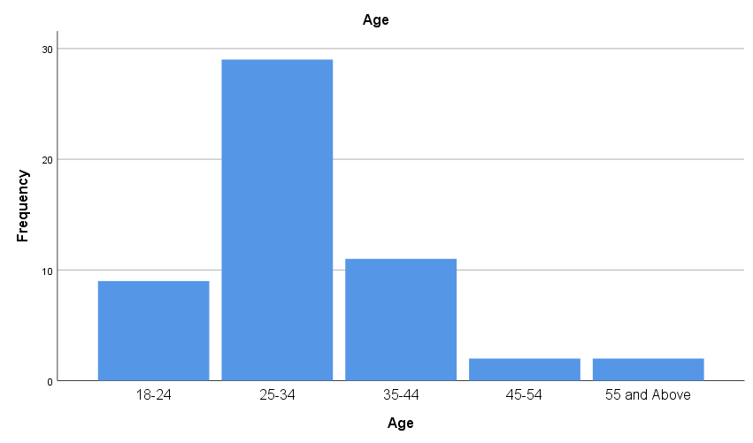
Chart 1: Age frequency chart

The data from derived from Chart 1 (Age Frequency Chart) of People Attending Kuching Tattoo Expo 2024 complements this theme by illustrating the demographic trends driving this resurgence. The chart reveals that a significant proportion of attendees at the Kuching Tattoo Expo are from younger generations, specifically those aged 18–35. This aligns with the narrative that younger Iban individuals are at the forefront of reviving and reinterpreting traditional tattoo practices.
For example, the chart indicates that 60% of attendees fall within the 18–24 age range, and 25% within the 26–34 age range, signifying a strong interest among these demographics in tattoos as expressions of identity. This data reflects how younger generations are embracing tattooing not just as an art form but as a medium to connect with and reinterpret their cultural heritage. By leveraging events like the Kuching Tattoo Expo, these individuals demonstrate an evolving appreciation for tattooing as a modern expression of Iban ethnicity and pride, bridging traditional motifs with contemporary styles.

- Urban Iban Reframe Tattoos as Symbols of Cultural Survival

Historically, Iban tattoos were deeply tied to spiritual beliefs and societal roles, marking bravery, protection, and beauty through significant life achievements. However, with the urbanisation of Iban communities, traditional tattoos have lost their roles as prominent spiritual and social markers, often viewed through a lens of stigma due to modern beliefs that categorise them as "pagan" (Salleh & Hashim, 2019). In response, younger urban Iban are reclaiming tattoos as symbols of cultural survival, transforming their meanings from spiritual to expressions of heritage and pride.
For many, tattoos represent a connection to their roots amid modernity’s pressures that threaten to erase traditional practices. By redefining tattoos as cultural symbols, the Iban community actively resists cultural erosion, ensuring that their heritage is not only preserved but revitalised in a manner that resonates with contemporary identities. This is supported by survey data showing that 64.2% of respondents strongly agree that Iban tattoo motifs contribute to the preservation of cultural identity as shown in table 1. This reframing is evident in several ways, such as the reinvention of motifs like the "Bunga Terung" (eggplant flower), shown as example in figure 1, or the "Tree of Life," which, although historically linked to significant life events, are now embraced as symbols of cultural pride (Salleh & Hashim, 2019). Additionally, events like the Kuching International Tattoo Expo serve as vital platforms for the urban Iban to celebrate tattooing as an artistic and cultural practice, aligning with their modern identity expressions.

Table 1: Iban tattoo motifs contribute to the preservation of cultural identity
 |  | Frequency | Percent | Valid Percent | Cumulative Percent
Valid | Strongly Disagree | 3 | 5.7 | 5.7 | 5.7
Valid | Agree | 1 | 1.9 | 1.9 | 7.5
Valid | Neutral | 3 | 5.7 | 5.7 | 13.2
Valid | Agree | 12 | 22.6 | 22.6 | 35.8
Valid | Strongly Agree | 34 | 64.2 | 64.2 | 100.0
Valid | Total | 53 | 100.0 | 100.0

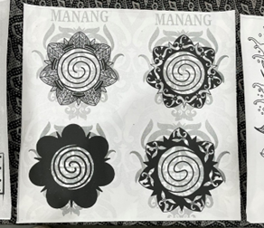
Figure 1 – Variations of Bunga Terung Motif
Source: Kuching Tattoo Expo 2024

- Tattoos Become Mediums of Cultural Continuity in a Globalised World

As urban Iban communities evolve, tattoos emerge as crucial cultural markers that facilitate continuity between traditional practices and contemporary identities. Urbanisation often threatens the preservation of indigenous cultural practices, leading to a shift towards cosmopolitan lifestyles (Salleh & Hashim, 2019). However, tattoos have become visual reminders of cultural lineage, bridging the gap between rural traditions and urban existence. Even in adapted forms, these tattoos continue to convey the symbols, aesthetics, and meanings central to Iban identity, albeit in a redefined context. This is supported by survey data in table 2, showing that 49.1% of respondents strongly agree that contemporary uses of Iban tattoo motifs contribute to the preservation of cultural identity. They act as cultural anchors, grounding urban Iban in their heritage while allowing for the embrace of modern identities. Thus, tattoos serve as tangible embodiments of the Iban narrative, ensuring its survival in the face of changing environments.
Examples include urban Iban professionals, for whom tattoos provide a physical and visual connection to their ethnic identity amidst modern work environments. Moreover, the participation of Iban tattoo artists in global tattoo festivals illustrates how tattoos function not only as personal markers but also as vehicles for the cultural continuity of the Iban narrative in a globalised context, countering the risk of assimilation faced by minority cultures as mentioned by Jonathan Cena (2024), a traditional tattoo artist from Manila, Philippines, “They will appreciate more of the culture of natives. It gives them education, just like how they’re very curious about the patterns and the tattoo so they will have the knowledge to study and ask the natives”.

Table 2: Contemporary uses of Iban tattoo motifs contribute to the preservation of cultural identity
 |  | Frequency | Percent | Valid Percent | Cumulative Percent
Valid | Strongly Disagree | 4 | 7.5 | 7.5 | 7.5
Valid | Disagree | 2 | 3.8 | 3.8 | 11.3
Valid | Neutral | 8 | 15.1 | 15.1 | 26.4
Valid | Agree | 13 | 24.5 | 24.5 | 50.9
Valid | Strongly Agree | 26 | 49.1 | 49.1 | 100.0
Valid | Total | 53 | 100.0 | 100.0

- Reinterpreting Traditional Practices to Align with Modern Values

A significant aspect of the urban Iban’s approach to tattoos lies in their reinterpretation of traditional practices to reflect modern values. For instance, while historical Iban tattoos were primarily masculine and signified warrior status or spiritual protection, contemporary practices are more inclusive, welcoming both men and women who opt for tattoos for aesthetic or cultural reasons. This reimagining highlights the resilience and adaptability of Iban culture, where traditions are not merely preserved but actively transformed to resonate with contemporary ideals of self-expression and personal empowerment. By doing so, the Iban have ensured that tattooing remains a living tradition, capable of evolving while retaining its core cultural significance.
This shift is exemplified by the growing gender inclusivity in tattoo choices and the modern interpretations of traditional designs, such as the "Bunga Terung" or "Tree of Life," which are now stylised to fit contemporary aesthetics. These adaptations not only maintain the essence of traditional motifs but also cater to the evolving preferences of modern audiences, showcasing the dynamic nature of Iban tattoo culture. Where in an interview, Jaban (2024) said “As I see the modified bunga terung, such as they will do a modern design, but they put in bunga terung along with the other designs. Like others, let’s say they did a design such as love, or dragons, without any colour but at the same time they put bunga terung there”. To back this up is a visual taken from Kuching Tattoo Expo 2024 where this individual added in the Bunga Terung motif into his tattoo in figure 2.

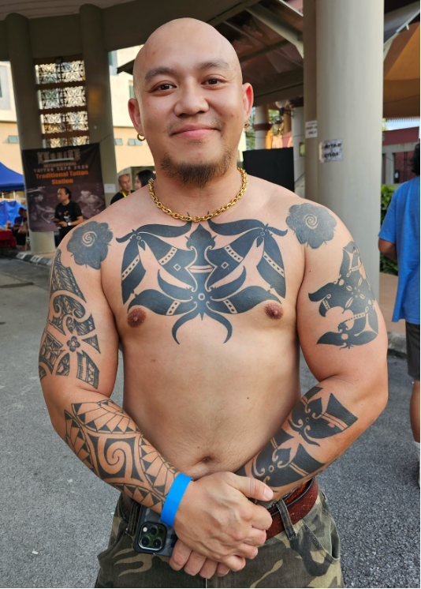
Figure 2 – Iban Tattoo with modern influences
Source: Kuching Tattoo Expo 2024

Aesthetics Adaption

The theme of Global Influences and Local Innovation underscores how tattooing within the urban Iban context transcends traditional boundaries, integrating various international styles such as Polynesian, Oriental, and Western trends. This blending is especially prominent in urban areas, where tattoo artists merge traditional motifs with contemporary designs to create hybrid forms that appeal to both local and global audiences. Globalisation has fostered an exchange of ideas and aesthetics, enabling Iban tattoos to become part of a broader transnational cultural landscape. This fusion enriches the visual vocabulary of Iban tattoos, enhancing their adaptability to contemporary contexts without diluting their cultural significance.

- Blending Traditional and Global Aesthetics

A hallmark of modern Iban tattoo culture is the incorporation of diverse international styles into traditional Iban designs. Urban tattoo artists, influenced by global trends through social media and cross-cultural exchanges, reinterpret Iban motifs to resonate with contemporary sensibilities. This fusion results in a hybrid art form that captivates younger, urban Iban individuals while also appealing to non-Iban clients seeking culturally significant tattoos. Traditional motifs, such as the "Bunga Terung," are being reimagined using bold lines and intricate patterns inspired by Polynesian tattooing, while elements from Oriental tattoo culture, like dragon or koi fish designs, find their way into Iban tattoos, particularly in urban centres with significant Iban populations.

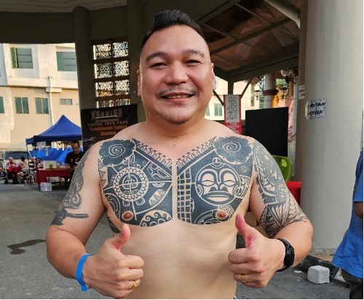
Figure 3 – Fusion Bunga Terung and Polynesian
Source: Kuching Tattoo Expo 2024

In figure 3, shows examples of the blending of styles which may exemplifies the fluid nature of tattoo culture, demonstrating that traditional designs can evolve and adapt to new artistic trends while retaining their cultural essence. It highlights the innovative spirit of Iban tattoo artists, who are committed to ensuring that their cultural expressions remain relevant and compelling in a global context.

- Tattoo Festivals as Platforms for Cultural Exchange

International tattoo festivals have emerged as vital venues for Iban tattoo artists to connect with global communities, facilitating the exchange of ideas and techniques (Chris Bishop, 2024). Events like the Kuching International Tattoo Expo and the Miri International Tattoo Festival foster cross-cultural interactions among tattooists from diverse backgrounds, promoting the sharing of styles, techniques, and cultural motifs (The Borneo Post, 2022). For Iban artists, these festivals offer opportunities to showcase their work to wider audiences while learning from peers across various cultures. Exposure to advanced tattooing equipment and innovative techniques enables Iban artists to enhance their skills while simultaneously preserving their cultural aesthetics (Chris Bishop, 2024).
Tattoo festivals thus act as cultural incubators, where traditional Iban tattooing is both preserved and transformed. They empower Iban artists to explore new designs and techniques while remaining grounded in their cultural heritage, illustrating how globalization can serve as a catalyst for both preservation and innovation within traditional art forms (Chris Bishop, 2024).

Cultural Fusion as a Form of Innovation

The incorporation of global styles into traditional Iban tattoo designs transcends mere aesthetic trends; it signifies deeper cultural negotiations (Salleh & Hashim, 2019). By integrating external influences into their tattoos, urban Iban artists assert their place within a globalised context while honouring their cultural heritage (Ibrahim & Tan, 2021). This cultural fusion enables them to express their identity in ways that resonate with contemporary urban life, characterised by pervasive cultural exchange (Nguyen & Lim, 2020). For many younger Iban, the choice to embrace tattoos that blend traditional motifs with modern styles reflects their dual identities rooted in indigenous heritage and contemporary urban influences (Salleh & Hashim, 2019).
An example of this duality is a modern tattoo in figure 4 taken at the Kuching Tattoo Expo 2024 and figure 5 tattoo by tattooist Willey Joe Ayu from Fearless Badger Tattoo Studio, that features the traditional "Tree of Life" motif in geometrical patterns, symbolising the wearer’s connection to both Iban culture and global trends (Ibrahim & Tan, 2021). This form of cultural fusion through tattooing empowers urban Iban to articulate complex identities, challenging the notion that traditional practices must remain unchanged to retain their significance (Nguyen & Lim, 2020).

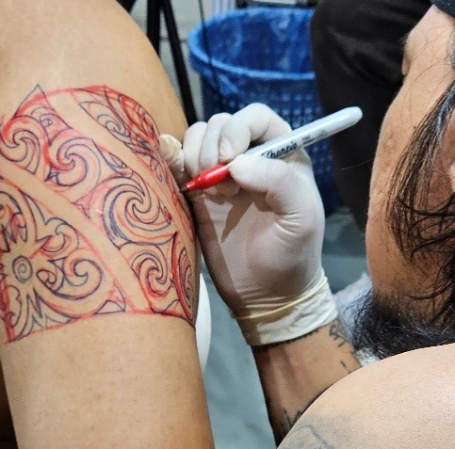
Figure 4 – Modernised “Tree of Life” tattoo tracing
Source: Kuching Tattoo Expo 2024

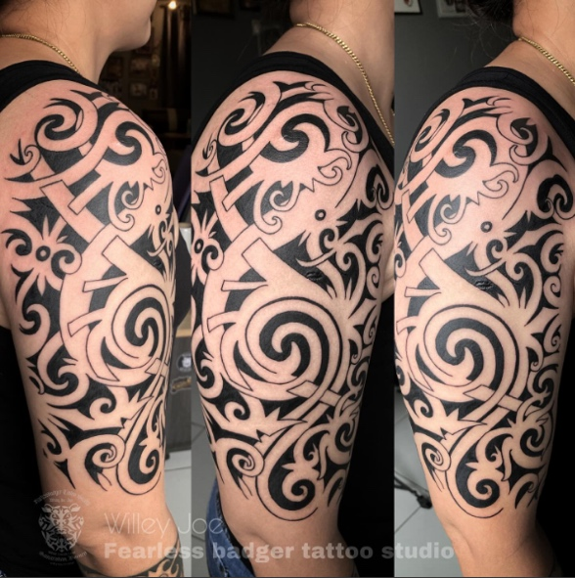
Figure 5 – Modernised Tree of life Tattoo
Source: Willie Joe Ayu (Fearless Badger Tattoo Studio)

Globalisation and the Redefinition of Authenticity

As global influences permeate Iban tattoo culture, discussions of authenticity become pertinent. While some may argue that the incorporation of foreign elements diminishes the traditional meaning of Iban tattoos, many urban Iban artists and wearers view this fusion as a genuine evolution of their cultural practice (Salleh & Hashim, 2019). They contend that Iban tattoos have always been dynamic, adapting over time to external influences, and that the current blending of global styles represents a continuation of this tradition.
In this context, authenticity is redefined, focusing on the capacity for innovation while maintaining connections to cultural roots. Survey results support this view, as shown in table 3, 49.1% of respondents strongly agree that contemporary tattoo culture should adapt to changing societal values, reflecting a willingness to embrace innovation while preserving cultural identity. The integration of global motifs with traditional Iban symbols reflects personal journeys and identities shaped by globalisation, underscoring the resilience of Iban culture as it adapts and evolves through various external influences while preserving its core significance.

Table 3: Contemporary tattoo culture should adapt to changing societal values
 |  | Frequency | Percent | Valid Percent | Cumulative Percent
Valid | Strongly Disagree | 2 | 3.8 | 3.8 | 3.8
Valid | Disagree | 4 | 7.5 | 7.5 | 11.3
Valid | Neutral | 7 | 13.2 | 13.2 | 24.5
Valid | Agree | 15 | 28.3 | 28.3 | 52.8
Valid | Strongly Agree | 25 | 47.2 | 47.2 | 100.0
Valid | Total | 53 | 100.0 | 100.0

Identity Reformation

Tattoos have emerged as significant instruments for urban Iban individuals to assert their ethnic and cultural identities within contemporary settings. Historically, Iban tattoos functioned as symbols of social status and spiritual protection. In the present context, they have evolved into markers of ethnic pride and individual expression, particularly for urban Iban navigating multicultural and modernised environments. By opting to wear traditional Iban motifs, individuals consciously affirm their connection to their heritage, reinforcing their ethnic identity in the face of pressures to assimilate within urban spaces (Ibrahim & Tan, 2021).
For many younger Iban, particularly those raised in urban settings, tattoos serve as a means to reconnect with their cultural roots in a society that often marginalises or dilutes their heritage. These tattoos act as visible, permanent expressions of personal narratives, ancestry, and cultural values. Additionally, they signify resistance against cultural homogenisation, affirming a sense of belonging to a specific cultural group in an increasingly globalised world (Nguyen & Mah, 2020).

- Tattoos as Statements of Empowerment and Cultural Reclamation

For urban Iban, the act of tattooing represents an empowering endeavour that enables them to reclaim their cultural heritage in a visible and permanent manner. Traditionally, Iban tattoos were deeply intertwined with rites of passage, spiritual beliefs, and social status, signifying attributes such as bravery, protection, or accomplishment (Ling & Whelan, 2020). Although the specific roles of these tattoos may have diminished over time, the practice is being re-contextualised in modern urban environments. By choosing to wear traditional tattoos, urban Iban individuals signal their connection to their ancestral roots and cultural history, which is particularly meaningful for those residing in cosmopolitan settings where their heritage may not be prominently recognised or acknowledged.
In contemporary society, tattoos transcend mere decorative body art; they have become powerful symbols of personal and cultural empowerment. For younger generations of urban Iban, acquiring traditional tattoos actively represents a reclaiming and honouring of their roots, asserting their ethnic identity in a globalised world. Survey data from table 3, underscoring this reclaiming of cultural elements. This act of body modification reflects a conscious decision to embody cultural narratives, thus resisting pressures to fully assimilate into modern urban life.
Key points regarding this theme include cultural reclamation, as tattoos allow Iban individuals to reclaim elements of their heritage that may have been diminished or lost due to colonialism, modernisation, and urban migration (Nguyen & Mah, 2020). Furthermore, tattoos provide a highly visible and personal form of cultural expression, enabling individuals to demonstrate pride in their heritage even in environments where such identities may be undervalued or overlooked.

- Resisting Cultural Homogenisation

In an era characterised by globalisation and urbanisation, indigenous and minority groups frequently confront pressures to conform to dominant cultural norms, leading to the erosion of their unique cultural practices. Tattoos serve as a counterforce to this homogenisation; by donning traditional Iban tattoos in urban settings, individuals assert their distinct cultural identity and resist the pressures of cultural assimilation (Ibrahim & Tan, 2021). This act of resistance is particularly potent in urban environments, where mainstream culture can overshadow minority identities.
The use of tattoos empowers Iban individuals to maintain a robust sense of identity, functioning both as a reminder of their cultural roots and as a declaration of their ongoing relevance in modern society. While urban life often prioritises global, cosmopolitan identities, tattoos anchor Iban individuals to their indigenous heritage. With the data from figure I shows that majority strongly agreed that Iban tattoo motifs contribute to the preservation of cultural identity, illustrating how tattoos bridge the gap between heritage and modernisation.

The reassertion of traditional symbols in public spaces challenges the notion that modernisation necessitates the abandonment of cultural traditions. Notable points within this discussion include cultural resistance, where tattoos facilitate the maintenance and assertion of unique identities against mainstream cultural pressures (Nguyen & Mah, 2020), and cultural pride, as the act of tattooing reinforces individual connections to their cultural lineage amidst external conformity pressures.

- Personal Narratives and Cultural Identity

For urban Iban, tattoos embody deeply personal connections that reflect both ancestral heritage and individual experiences. Modern tattoos often blend traditional Iban motifs with contemporary designs, allowing wearers to articulate unique stories that encompass both their personal journeys and cultural backgrounds. This fusion of tradition and modernity exemplifies the fluidity of identity, illustrating how individuals navigate and reconcile their cultural heritage with urban, modern lifestyles (Ling & Whelan, 2020).
The decision to obtain a tattoo frequently involves reclaiming ancestral narratives while incorporating personal layers of meaning. Survey data in figure X indicates that 41.5% of respondents strongly agree that contemporary Iban tattoo motifs hold personal significance, reflecting the merging of personal and cultural narratives. For instance, the traditional Bunga Terung (eggplant flower) motif, which may have historically symbolised a rite of passage, is now reinterpreted to include elements reflecting the wearer's individual life experiences, such as global motifs or modern tattoo styles (Ibrahim & Tan, 2021).
In this manner, tattoos evolve into living narratives that honour the past while embracing contemporary realities. Key points include personal storytelling, as tattoos offer a medium for individuals to intertwine their personal stories with their cultural history, and dynamic identity, wherein Iban individuals articulate a multifaceted sense of identity that harmonises traditional heritage with modern existence.

Table 4: Contemporary Iban tattoo motifs hold personal significance for me
 |  | Frequency | Percent | Valid Percent | Cumulative Percent
Valid | Strongly Disagree | 9 | 17.0 | 17.0 | 17.0
Valid | Disagree | 2 | 3.8 | 3.8 | 20.8
Valid | Neutral | 13 | 24.5 | 24.5 | 45.3
Valid | Agree | 7 | 13.2 | 13.2 | 58.5
Valid | Strongly Agree | 22 | 41.5 | 41.5 | 100.0
Valid | Total | 53 | 100.0 | 100.0

- Community Cohesion and Belonging

Beyond individual significance, tattoos also serve as markers of belonging and community cohesion among urban Iban. For many, the act of getting a tattoo transcends individualism, positioning them within a broader cultural resurgence. Tattoos foster a collective sense of identity among Iban individuals, facilitating connections to their ethnic group, especially when distanced from their rural origins (Nguyen & Mah, 2020).
Tattoo festivals, studios, and cultural events celebrating traditional Iban tattooing offer communal spaces for the practice to flourish. Such gatherings cultivate a sense of collective identity and shared heritage, reinforcing bonds within the urban Iban community. Survey data through table 5 indicates that 49.1% of respondents strongly agree that the urban Iban community should actively participate in shaping contemporary tattoo culture, reflecting the importance of such communal spaces for cultural continuity.
By engaging in these cultural activities, individuals not only strengthen their ties to their ancestry but also contribute to the continuity of Iban traditions within urban contexts. Important points include collective identity, as tattoos foster a shared sense of belonging among urban Iban, and community spaces, where tattoo festivals and studios function as cultural hubs for celebrating and fortifying connections to heritage (Ling & Whelan, 2020).

Table 5: The urban Iban community should actively participate in shaping contemporary tattoo culture
 |  | Frequency | Percent | Valid Percent | Cumulative Percent
Valid | Strongly Disagree | 1 | 1.9 | 1.9 | 1.9
Valid | Disagree | 2 | 3.8 | 3.8 | 5.7
Valid | Neutral | 11 | 20.8 | 20.8 | 26.4
Valid | Agree | 13 | 24.5 | 24.5 | 50.9
Valid | Strongly Agree | 26 | 49.1 | 49.1 | 100.0
Valid | Total | 53 | 100.0 | 100.0

- Navigating Modernity and Tradition

For urban Iban, tattoos symbolise the complex navigation of the tension between modernity and tradition. While urban life often necessitates adaptation to new ways of thinking, working, and living, many Iban individuals feel a profound obligation to remain connected to their cultural roots, particularly amidst rapid social changes (Ibrahim & Tan, 2021).
By choosing traditional tattoos, urban Iban individuals successfully integrate both aspects of their identity—modern and traditional. Survey data as shown in table 6 reveals that 47.2% of respondents strongly agree that a sustainable visual culture can be achieved through contemporary tattooing practices, illustrating how tattoos bridge this duality. Tattoos serve as symbolic reminders of their cultural heritage while simultaneously enabling participation in the globalised sphere of modern tattooing.
This duality is central to their experience, reflecting continuity with the past alongside adaptability for the future. Key points of emphasis include the balance between modernity and tradition, as tattoos allow Iban individuals to maintain connections to their heritage while adjusting to the demands of urban life, and cultural continuity, as tattoos bridge past traditions with contemporary identity, ensuring that cultural practices not only endure but evolve (Nguyen & Mah, 2020).

Table 6: A sustainable visual culture can be achieved through contemporary tattooing practices
 |  | Frequency | Percent | Valid Percent | Cumulative Percent
Valid | Strongly Disagree | 1 | 1.9 | 1.9 | 1.9
Valid | Disagree | 3 | 5.7 | 5.7 | 7.5
Valid | Neutral | 9 | 17.0 | 17.0 | 24.5
Valid | Agree | 15 | 28.3 | 28.3 | 52.8
Valid | Strongly Agree | 25 | 47.2 | 47.2 | 100.0
Valid | Total | 53 | 100.0 | 100.0

Conclusion

In conclusion, the resurgence of Iban tattoo culture in urban Sarawak exemplifies a powerful interplay between tradition and modernity, identity and resistance, as well as individual and collective empowerment. Urban Iban individuals, particularly the youth, have redefined tattooing as a vehicle for cultural reclamation and resistance against cultural homogenisation (Salleh & Hashim, 2019). This adaptation ensures the survival of indigenous practices in an increasingly globalised world while fostering a dynamic identity that honours ancestral roots. As demonstrated through ethnographic studies and events like the Kuching International Tattoo Expo, tattoos now serve as potent symbols of continuity, adaptability, and pride (Ibrahim & Tan, 2021). These cultural markers connect individuals to their heritage while simultaneously enabling them to engage with broader, global trends. Ultimately, the practice highlights the resilience and innovation of the Iban community in preserving their identity amidst the challenges of urbanisation and modernity.

Acknowledgment
The authors would like to thank the Ministry of Higher Education (MoHE), Malaysia and the University Malaysia Sarawak (UNIMAS) for funding Project, with the Project No: NAT/F03/FRGS/86010/2023. The authors would like to thank the Faculty of Applied and Creative Arts, UNIMAS; Faculty of Social Sciences and Humanities, UNIMAS for supporting this research.

References

Anak Saging, A. (2019). Traditional tattoos of the Iban people of Sarawak: Their symbolism and meanings [Unpublished undergraduate thesis]. Universiti Malaysia Sarawak.

Ayu, W. J. [@willeyjoeayu]. (2023, November 21). Borneo Tree of Life Tattoo [Instagram post]. Instagram. https://www.instagram.com/willeyjoeayu/p/Cz5r3BRPB0Z/

Barthes, R. (1967). Elements of semiology. Hill and Wang.

Braun, V., & Clarke, V. (2006). Using thematic analysis in psychology. Qualitative Research in Psychology, 3(2), 77–101. https://doi.org/10.1191/1478088706qp063oa

Chandler, D. (2007). Semiotics: The basics (2nd ed.). Routledge

Chris Bishop. (2024, April 6). Tatu motif Iban, Bidayuh atau Orang Ulu bawa identiti Sarawak ke seluruh dunia. DayakDaily. https://dayakdaily.com/tatu-motif-iban-bidayuh-atau-orang-ulu-bawa-identiti-sarawak-ke-seluruh-dunia/

Eco, U. (1976). A theory of semiotics. Indiana University Press
Ibrahim, A., & Tan, P. Y. (2021). Hybrid identities and cultural preservation: The evolution of traditional art in contemporary contexts. Journal of Cultural Studies, 15(4), 321–338.

Ibrahim, H., & Tan, C. (2021). Urban Indigenous identity: Reclaiming heritage through visual arts. Asian Ethnology, 80(1), 89–108.

Iedema, R. (2003). Multimodality, resemiotization: Extending the analysis of discourse as multi-semiotic practice. Visual Communication, 2(1), 29–57.

Cena, J., & Sioson, J. (2024, July 28). Interview. Miri Tattoo Festival 2024.

Kanyan, R. (2024). Sustainable contemporary Iban tattoo conservation framework through cultural semiotics theory[Unpublished raw data]. Universiti Malaysia Sarawak.

Kress, G., & van Leeuwen, T. (2006). Reading images: The grammar of visual design (2nd ed.). Routledge.

Ling, S. H., & Whelan, T. (2020). Body art as cultural heritage: Iban tattooing in urban contexts. Journal of Southeast Asian Studies, 51(2), 245–265.

Logan, W. (2001). Globalizing heritage: World heritage as a manifestation of modernism and challenges from the periphery. In R. Harrison & C. Williamson (Eds.), Heritage and globalisation (pp. 33–44). Routledge.

Lotman, Y. M. (1990). Universe of the mind: A semiotic theory of culture. I. B. Tauris.

Masing, J. (1981). The coming of the gods: An Iban invocatory chant (timang gawai ampun). Athlone Press.

Mohd Shah, J. (2019). Motif tattoo Iban Sarawak: Makna dan perlambangan dalam masyarakat Iban [Unpublished undergraduate thesis]. Universiti Malaysia Sarawak.

Nguyen, L., & Mah, C. (2020). Globalisation and minority identity: Cultural resistance in Southeast Asia. Journal of Cultural Studies, 15(3), 217–234.

Nguyen, T., & Lim, J. (2020). Tattooing in a globalised world: Cultural intersections and innovation. International Journal of Art and Culture, 10(3), 101–118.

Jaban, P. J. (2024, July 28). Interview. Miri Tattoo Festival 2024.

Salleh, M., & Hashim, F. (2019). Iban tattooing in contemporary practice. Journal of Cultural Identity, 12(2), 123–135.

Smith, L. (2006). Uses of heritage. Routledge.

Soda, K. (2000). Cultural continuity and change among the Iban people of Sarawak. Asian Studies Journal.

Sutlive, J. (1977). The Iban of Sarawak: History, culture, and transformation. Sarawak University Press.

The Borneo Post. (2022, October 1). KTF 2022 makes debut with local, international tattoo artists. Borneo Post Online. https://www.theborneopost.com/2022/10/01/ktf-2022-makes-debut-with-local-international-tattoo-artists/

United Nations Educational, Scientific and Cultural Organization (UNESCO). (2003). Convention for the safeguarding of the intangible cultural heritage. UNESCO.

