

Borneo International Journal of Biotechnology (BIJB)
Vol. 2 (December 2022), 1 – 13
e-ISSN

Optimization of a GC-MS metho for the detection of bioactive compounds from the green peel

pomelo cultivar ‘PO52’
Teoh Peik Lin1, Jabi Tananak2 and Cheong Bo Eng1*
1 Biotechnology Research Institute, Universiti Malaysia Sabah, Kota Kinabalu, Sabah, Malaysia
2 Agriculture Research Station, Tenom, Sabah, Malaysia
*Corresponding author’s email: becheong@ums.edu.my https://doi.org/10.51200/bijb.v2i.3129
Received: 16 November 2021 | Revised: 26 April 2022 | Accepted: 28 June 2022 | Published:

ABSTRACT
Pomelo is the largest and most popular citrus fruit known to possess diverse health benefits. Sabah’s fruit basket, Tenom, is famous for pomelo production. Among the pomelo cultivars being planted in Tenom, the PO52 cultivar is the most abundant one. To date, the bioactive compounds of the PO52 cultivar are not well studied. Although numerous aroma-active compounds from the peels of Malaysian pomelo have been reported, there are still many potential non-aromatic bioactive compounds that are yet to be discovered. In this study, we analysed the peel extract of pomelo PO52 using gas chromatography coupled to a single quadrupole mass spectrometry (GC-MS) approach. We first analysed the pomelo peel extracts using two different GC-MS methods, one can detect 45 organic compounds with good separation, while the other can detect phytosterols and pentacyclic triterpenoids in Clinacanthus nutans roots. In our study, these two methods were able to detect bioactive compounds from the pomelo peels but with a longer running time and the generated total ion chromatograms (TIC) were also not smooth. Therefore, we further optimized the two methods by changing the temperature ramping and holding times of the GC-MS. Compared to the first two methods, the optimized method had the shortest total running time (38 min) and the total ion chromatogram (TIC) produced was smooth throughout the run time. Furthermore, bioactive compounds that have not been reported for pomelo peel before, such as osthole, α-tocopherol, gamma-sitosterol, friedelan-3-one and others were also detected using this optimized method. In conclusion, the optimized method is suitable for the detection of non-aromatic compounds present in the PO52 peels that can be subsequently applied in the next stage for large-scale analysis.
Keywords: GC-MS, pomelo, peel, albedo, flavedo, bioactive compounds, Tenom

INTRODUCTION
Pomelo (Citrus grandis (L.) Osbeck) is one of the most common citrus fruits grown in China and Southeast Asia regions. In Malaysia, the fruit is also known as pommelo, limau betawi, limau bali, limau besar or shaddock. Currently, there are a few popular cultivars of pomelo cultivated in Malaysia. They are PO52 (Tambun), PO51 (Sha Thing), KK2’(‘Melomas’) and a new hybrid PO55 (Ledang) with sweeter fruits and less bitter aftertaste that was introduced by the Malaysia Department of Agriculture (http://www. doa.gov.my/) in 2010 (Chang & Azrina, 2017).
The typical pomelo fruit consists of the flesh, peel, segment membrane and pulp parts. Pomelo flesh is usually eaten fresh while the peel, segment membrane and pulp are discarded as waste (Zarina & Tan, 2013). The peel of pomelo consists of two parts which are flavedo (the green colour outer layer), and albedo (the inner layer with a white spongy texture), while the fruit flesh/ pulps are covered with a tough skin known as enveloping/ segment membrane (Chang & Azrina, 2017). The edible pulps and inedible peel of pomelo have been reported to possess phenolic and flavonoid contents, as well as antioxidant activities (Mäkynen et al., 2013; Toh et al., 2013; Chang & Azrina, 2017). In addition, the pomelo peel also contains aroma-active volatiles, pectin, carotenoids and polysaccharides (Tocmo et al., 2020). The peel of pomelo accounts for approximately 30% of the total fruit weight, but this part is always regarded as waste and thrown in landfills. As the pomelo peel contains various health-promoting phytochemicals, recovery of these phytochemicals from the peels offers great potential for the development of enriched functional foods and nutraceuticals (Tocmo et al., 2020).
Tenom is a district located in the interior division of Sabah, Malaysia. It is known as Sabah’s fruit basket. This is because Tenom is blessed with fertile lands and its surrounding area has made it primarily an agricultural area. Tenom is famous for the planting and production of pomelo and other tropical fruits. The three pomelo cultivars that are currently being planted and produced in Tenom are PO51, PO52 and Melomas. In Tenom, PO52 is the most abundantly planted cultivar due to its popularity among consumers as the flesh of the fruit is pinkish, juicy and sweet (source: from the Tenom Agriculture Research Station Office, Sabah, Malaysia). The Sabah State Government, through the Rural Development Corporation, is in the process of planning several programmes to attract interested Sabahans to be involved in pomelo cultivation. It is estimated that an acre of about 55 pomelo trees can fetch up to eight tonnes of pomelo a year, which is worth about RM20,000 at RM2.50 per kg, meaning that five acres of pomelo are able to draw roughly RM100,000 a year (Daily Express, 2020). The large-scale production of pomelo, especially the PO52 cultivar from Tenom per year may therefore offer great sources of peels having valuable bioactive compounds for the development of enriched functional foods and nutraceuticals.

To date, not many studies have been reported on the bioactive compounds present in the whole fruit of the PO52 cultivar. Toh et al. (2013) via the in vitro spectrophotometry assays have reported that the peels of both PO52 Tambun White and PO52 Tambun Pink cultivars contained higher total phenolic content, total flavonoid content and in vitro antioxidant capacities compared to their pulps. Meanwhile, Cheong et al. (2013) via gas chromatography coupled with flame ionization detector (GC-FID/MS) and gas chromatography-olfactometry (GC-O) approaches, identified more than 50 and 47 volatile aroma-active compounds in peel extracts of Malaysian pink and white pomelo, respectively. A wide range of volatile aroma-active compounds detected in the peels was α-pinene, β-pinene, limonene, linalool, geraniol and others. However, the cultivars used were not mentioned.
Despite this, we believe that there are still many potentially bioactive compounds which are not aromatic also present yet to be discovered. Therefore, we aimed to study these non-aromatic bioactive compounds from the peels of the PO52 cultivar using gas chromatography coupled with single quadruple mass spectrometry (GC-MS). Employing GC-MS in our current study offers several advantages, i.e. it is robust, easy to handle, and comes with a library (NIST database) in which we can match and analyse our data conveniently. We have optimized a GC-MS method for the detection of non-aromatic bioactive compounds. The developed method has successfully detected some bioactive compounds such as osthole, α-tocopherol, γ-sitosterol and friedelan-3-one which have not been found previously.

MATERIALS AND METHODS

Plant Materials
A large size of fresh pomelo fruit (cultivar ‘PO52’) was purchased from a local fruit supplier from Tenom, Sabah (Figure 1a). The fruit was washed thoroughly and dried with a towel, and then the pulps and peels were separated. The peels were further separated into flavedo (the greenish outer layer) and albedo (the whitish spongy inner layer) as shown in Figure 1b. The pomelo materials were freeze-dried, lyophilised and stored at −80°C prior to extraction.

Extraction of Pomelo Peels
The extraction of the flavedo of pomelo was performed according to the method described by Teoh et al. (2017), with some modifications. Briefly, two grams of frozen peel powder were dissolved in 20 mL of absolute methanol. The mixture was vortexed and sonicated for 30 min at 30°C. Then, the mixture was macerated in a rotary shaker for 24 hrs at 37°C, in dark conditions. After that, the mixture was filtered first with filter paper, followed by a second filtration using a 0.22 µm syringe filter. The extracts obtained were dried under vacuum pressure and stored at −20°C until further analysis.

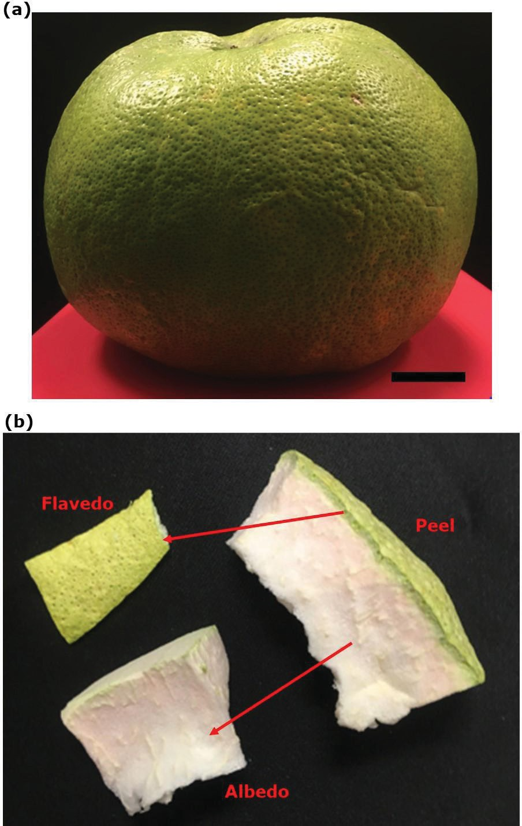
Figure 1 (a) A large-size of pomelo cultivar ‘PO 52’ was purchased from a fruit supplier in Tenom and used in this study. (b) The peel of the pomelo was dissected into the greenish part (flavedo) and whitish spongy part (albedo), followed by freeze-drying. Bar length under the fruit in (a) = 3 cm.

GC-MS Analysis Based on Method 1 Described by Teoh et al. (2017)
The dried peel extract was re-dissolved in HPLC-grade methanol to an appropriate concentration (1,000 ppm). Then, the extract (1 µL) was injected into a GC-MS (GC model 7890, MS model 5975C, Agilent Technologies, Santa Clara, CA). GC separation was performed on an HP-5MS capillary column (30 m × 0.25 mm × 0.25 µm, Agilent Technologies, Santa Clara, CA) operating at electron impact mode at 70 eV. Pure helium gas with a built-in purifier was used at a constant flow rate of 1 mL/min employed in a splitless mode with an injector at 250°C and an ion source at 280°C. The stepped temperature programme was as follows: initial oven temperature was started at 220°C and held for 5 min, followed by a ramp to 300°C at 5°C/min and held for another 15 min. The total run time for one sample was therefore 41 min. A mass analyzer was used in full scan mode scanning from m/z (mass-to-charge ratio) 40 to 550 and mass spectra were taken at 70 eV. The identification of compounds was based on the comparison of their mass spectra with the library of National Institute Standard and Technology (NIST) version 2.0.

GC-MS Analysis Based on Method 2 Described by Dias et al. (2015)
For the GC-MS method modified from Dias et al. (2015), the 1 µL extract was injected into the same GC-MS model and operated in the same conditions as mentioned in part 2.3 except for the stepped temperature program. The initial oven temperature was started at 70°C and held for 1 min, followed by a ramp to 325°C at 7°C/min and held for another 6 min. The total run time for one sample was therefore 43 min. The compounds were identified using the same database.

Optimization of GC-MS Conditions (Method 3)
After comparing the results obtained from the above-mentioned methods, the parameters for the stepped temperature program were further modified by starting the initial oven temperature at 50°C and holding for 3 min, followed by a ramp to 300°C at 10°C/min and holding for another 10 min. The total run time for one sample now became 38 min.

RESULTS AND DISCUSSION

GC-MS Results Obtained Based on Method 1 Described by Teoh et al. (2017)
As there were too many peaks detected for each method, only the peaks with a possible score of more than 70% (spectra matching with the NIST library) were treated as possible identified compounds. According to Stein (1999), the identification of compounds based on the NIST library is reliable when the possibility is above 80, often accurate if it falls between 70 and 79, and considered uncertain between 60 and 69. From the GC-MS results analysed using the method adopted by Teoh et al. (2017), only three bioactive compounds with a possible score of more than 70% were detected (Figure 2). As shown in Table 1, these three compounds were α-tocopherol, γ-sitosterol and friedelan-3-one. These three compounds have been reported to possess bioactivities. For example, α-tocopherol was found to have anticancer (Ramdas et al., 2011) and antioxidant activities (Kontush et al., 1996), γ-sitosterol with anticancer and apoptotic properties (Awad et al., 2003; Chai et al., 2008; Sundarraj et al., 2012), and friedelan-3-one with antimicrobial activity (Odeh et al., 2016). We noticed that this GC-MS method was not suitable to detect bioactive compounds from the pomelo peel extract. Therefore, we chose another method (Dias et al., 2015) to re-analyse the peel extract.
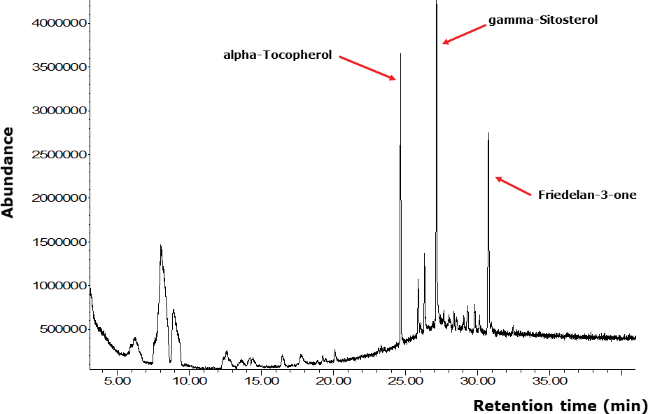
Figure 2 A total ion chromatogram of the pomelo peel extract was detected using the GC-MS method adopted by Teoh et al. (2017). Compounds with bioactivities were labelled and shown.

Table 1 Compounds detected using the three GC-MS methods
Number of detected compounds
GC-MS with Retention Area
method possibility time (%) Hit name Bioactivity
score of (min)
more than 70%
Teoh et al. 1 | 24.655 | 8.2 | α-Tocopherol | Anticancer
(2017) |  |  |  | (Ramdas et al.,
 |  |  |  | 2011); Antioxidant
 |  |  |  | (Kontush et al.,
 |  |  |  | 1996)
2 | 27.151 | 13.2 | γ-Sitosterol | Anticancer (Awad et
 |  |  |  | al., 2003), Apoptotic
 |  |  |  | (Chai et al., 2008
 |  |  |  | and Sundarraj et al.,
 |  |  |  | 2012)
3 | 30.754 | 7.2 | Friedelan-3-one | Antimicrobial (Odeh
 |  |  |  | et al., 2016)
Modified 1 | 8.110 | 3.2 | 4H-Pyran-4-one, 2,3-dihydro-3,5-
Dias et al. |  |  | dihydroxy-6-methyl-
(2015) 2 | 9.699 | 4.6 | 5-Hydroxymethylfurfural | Antioxidant and
 |  |  |  | antiproliferative
 |  |  |  | (Zhao et al., 2013)
3 | 10.218 | 0.1 | 1,2-Benzenediol, 3-methyl-
4 | 11.181 | 0.5 | 2-Methoxy-4-vinylphenol
5 | 14.703 | 1.1 | Phenol, 2,4-bis(1,1-dimethylethyl)-
6 | 19.689 | 0.4 | Cyclononasiloxane, octadecamethyl-
7 | 23.986 | 0.5 | 7,10,13-Hexadecatrienoic acid, methyl
 |  |  | ester
8 | 24.105 | 1.0 | Osthole | Antioxidant and
 |  |  |  | anti-inflammatory
 |  |  |  | (Yang et al., 2014)
9 | 24.336 | 0.4 | Ethyl Oleate
10 | 31.736 | 0.2 | 2,6,10,14-Hexadecatetraenoic acid,
 |  |  | 3,7,11,15-tetramethyl-, ethyl ester
11 | 34.701 | 4.2 | α-Tocopherol | Anticancer
 |  |  |  | (Ramdas et al.,
 |  |  |  | 2011); Antioxidant
 |  |  |  | (Kontush et al.,
 |  |  |  | 1996)
12 | 35.640 | 1.2 | Campesterol | Anticancer (Awad et
 |  |  |  | al., 2003)
13 | 35.927 | 1.5 | Dibenzo[a,h]cyclotetradecene,
 |  |  | 2,3,11,12-tetraethyl-
 |  |  | 1,2,3,4,5,6,7,8,9,10,11,12,13,14,15,16,17,18-
 |  |  | octadecahydro-,
 |  |  | (2R*,3S*,4Z,9Z,11R*,12S*)-

 | 14 | 36.447 | 6.4 | β-Sitosterol | Anticancer (Awad et
 |  |  |  |  | al., 2003); Apoptotic
 |  |  |  |  | (Chai et al., 2008
 |  |  |  |  | and Sundarraj et al.,
 |  |  |  |  | 2012)
 | 15 | 37.185 | 0.4 | 9,10-Methanoanthracen-11-ol,
 |  |  |  | 9,10-dihydro-9,10,11-trimethyl-
 | 16 | 38.423 | 3.8 | Friedelan-3-one | Antimicrobial (Odeh
 |  |  |  |  | et al., 2016)
Optimi- | 1 | 5.533 | 1.1 | 2-Furanmethanol | Antiviral,
zed |  |  |  |  | antibacterial
GC-MS |  |  |  |  | and anti-fungal
method |  |  |  |  | (Premathilaka &
 |  |  |  |  | Silva, 2016)
 | 2 | 9.336 | 0.58 | 2,5-Piperazinedione, 3-methyl- | Inhibit quorum
 |  |  |  |  | sensing-dependent
 |  |  |  |  | factor production
 |  |  |  |  | in Pseudomonas
 |  |  |  |  | aeruginosa
 |  |  |  |  | (Musthafa et al.,
 |  |  |  |  | 2012)
 | 3 | 10.781 | 2.0 | 4H-Pyran-4-one, 2,3-dihydro-3,5-
 |  |  |  | dihydroxy-6-methyl-
 | 4 | 11.994 | 2.6 | 5-Hydroxymethylfurfural | Antioxidant and
 |  |  |  |  | antiproliferative
 |  |  |  |  | (Zhao et al., 2013)
 | 5 | 13.158 | 0.35 | 2-Methoxy-4-vinylphenol
 | 6 | 15.691 | 2.9 | Phenol, 2,6-bis(1,1-dimethylethyl)-
 | 7 | 20.539 | 0.3 | Tridecanoic acid
 | 8 | 22.391 | 1.1 | Osthole | Antioxidant and
 |  |  |  |  | anti-inflammatory
 |  |  |  |  | (Yang et al., 2014)
 | 9 | 22.497 | 0.6 | Ethyl Oleate
 | 10 | 30.247 | 4.0 | α-Tocopherol | Anticancer
 |  |  |  |  | (Ramdas et al.,
 |  |  |  |  | 2011); Antioxidant
 |  |  |  |  | (Kontush et al.,
 |  |  |  |  | 1996)
 | 11 | 32.524 | 5.5 | γ-Sitosterol | Anticancer (Awad et
 |  |  |  |  | al., 2003); Apoptotic
 |  |  |  |  | (Chai et al., 2008
 |  |  |  |  | and Sundarraj et al.,
 |  |  |  |  | 2012)
 | 12 | 36.015 | 3.8 | Friedelan-3-one | Antimicrobial (Odeh
 |  |  |  |  | et al., 2016)

GC-MS Results Obtained Based on the Method 2 Described by Dias et al. (2015)
Using the method adopted by Dias et al. (2015), more compounds with a score of more than 70% were detected (Figure 3). From Table 1, there were 16 compounds, of which six have been reported to possess bioactivities. The six bioactive compounds were 5-hydroxymethylfurfural, osthole, α-tocopherol, campesterol, β-sitosterol and friedelan-3-one. Apart from those compounds that have been discussed in part 3.1, both 5-hydroxymethylfurfural and osthole were found to possess antiproliferative and anti-inflammatory activities, respectively (Zhao et al., 2013; Yang et al., 2014). Besides, campesterol was known to have anticancer activity (Awad et al., 2003). Although more bioactive compounds could be detected using this GC-MS method, the total running time per sample was 43 min, which was lengthy and might be time-consuming if large-scale peel samples are to be analysed in the future. Furthermore, the total ion chromatogram (Figure 3) obtained via this method was not smooth from 35 min onwards. Therefore, we decided to further optimize this method by modifying the ramping temperature and holding time.
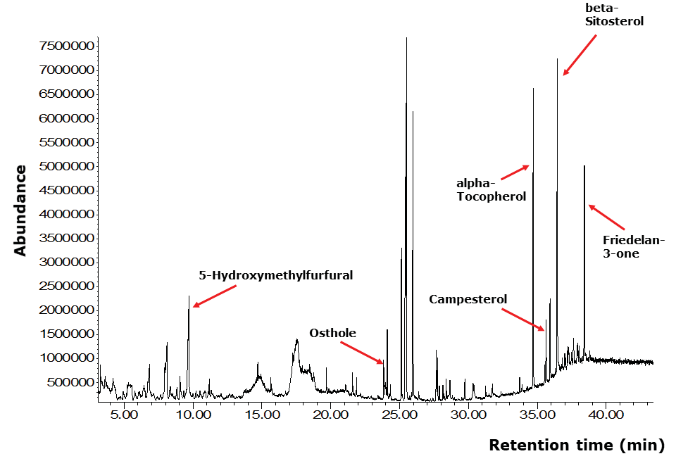
Figure 3 Total ion chromatogram of the pomelo peel extract detected using the GC-MS method adopted and modified by Dias et al. (2015). Compounds with bioactivities were labelled and shown.

GC-MS Results Obtained Based on the Optimized Method (Method 3)
From the GC-MS results analysed using the optimized GC-MS method in which the ramping temperatures and holding times have been modified, it is obvious that the TIC now became smoother throughout the running time (Figure 4). The majority of the peaks (compounds) were separated nicely in the chromatogram. This could be due to the chemical characteristic of the compounds present in the pomelo peel extract that is suitable to be separated using the modified temperature ramping and holding time per each gradient. In addition, the total running time was reduced from 43 min (Dias et al., 2015) to 38 min per sample. Besides, 12 compounds with >70% score was obtained (Table 1). Of these, five were bioactive compounds which were also detected using Dias et al., 2015 (Figure 4). There were also four compounds which were not detected using the first two methods but were detected using this optimized method. They were 2-furanmethanol, tridecanoic acid, 2,5-piperazinedione-3-methyl-, and phenol, 2,6-bis(1,1-dimethylethyl)-.Of these, the 2-furanmethanol has been reported to possess antiviral, antibacterial and antifungal activities by Premathilaka and Silva (2016). Meanwhile, Musthafa et al. (2012) reported the activity of 2,5-Piperazinedione to inhibit quorum sensing-dependent factor production in Pseudomonas aeruginosa.
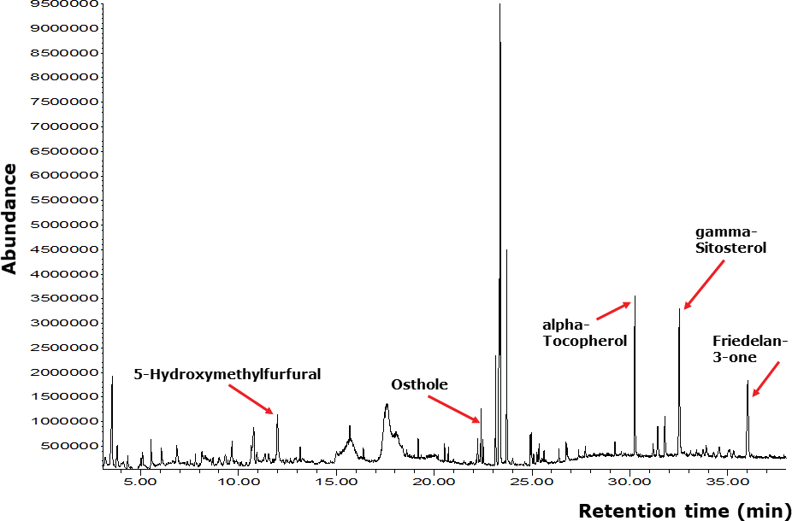
Figure 4 Total ion chromatogram of the pomelo peel extract detected using the optimized GC-MS method.
Compounds with bioactivities and an abundance of more than 800,000 were labelled and shown.

CONCLUSION
In conclusion, the optimized GC-MS method can be considered a suitable method for the detection of bioactive compounds from the peels of pomelo cultivar ‘PO52’. This method may be subsequently applied in the large-scale analysis of PO52 peel extract. Besides, the method can be further optimized to better separate as well as identify with certainty of more bioactive compounds from the other parts of the pomelo, i.e the flesh and segment membranes. The phytochemical compositions of pomelo may provide insightful information for Sabah farmers and nutraceutical industries about the potential pharmaceutical values of pomelo cultivars planted in Sabah.

ACKNOWLEDGEMENTS
The authors thank the Biotechnology Research Institute of Universiti Malaysia Sabah for providing the laboratory and equipment to support this research. The authors also thank the Agriculture Research Station (ARS), Tenom, Sabah for providing important information about the pomelo plantation in Sabah.

REFERENCES
Abudayeh, Z. H., Al Khalifa, I. I., Mohammed, S. M., & Ahmad, A. A. J. P. R. (2019). Phytochemical content and antioxidant activities of pomelo peel extract. Pharmacognosy Res., 11 (3),
244. Doi: 10.4103/pr.pr_180_18. https://doi.org/10.4103/pr.pr_180_18
Awad, A. B., Williams, H., & Fink, C. S. (2003). Effect of phytosterols on cholesterol metabolism and MAP kinase in MDA-MB-231 human breast cancer cells. J Nutr Biochem., 14 (2), 111 – 119. https://doi.org/10.1016/S0955-2863(02)00274-7
Barrion, A. S., Hurtada, W. A., Papa, I. A., Zulayvar, T. O., & Yee, M. G. (2014). Phytochemical composition, antioxidant and (Citrus maxima (Burm.)) Merr. against Escherichia typhimurium. Food Nutr Sci., 5 (9), 749 – 758. https://doi.org/10.4236/fns.2014.59085
Chai, J. W., Kuppusamy, U. R., & Kanthimathi, M. S. (2008). Beta-Sitosterol induces apoptosis in MCF-7 cells. Malaysian J Biochem Mol Biol., 16, 28 – 30.
Chang, S. Q., & Azrina, A. (2017). Antioxidant content and activity in different parts of pomelo [Citrus grandis (L.) Osbeck] by-products. ISHS Acta Horticulturae 1152: International Conference on Agricultural and Food Engineering, 27 – 34. https://doi.org/10.17660/ ActaHortic.2017.1152.4
Cheong, M. W., Liu, S. Q., Yeo, J., Chionh, H. K., Pramudya, K., Curran, P., & Yu, B. (2011). Identification of aroma-active compounds in Malaysian pomelo (Citrus grandis (L.) Osbeck) peel by chromatography-olfactometry. J Essential Oil Res., 23 (6), 34 – 42. https://doi.org/10.1 080/10412905.2011.9712279
Getting Sabahans involved in agriculture. (2020, May 21). Daily Express. Retrieved from https:// www.dailyexpress.com.my/news/153127/getting-sabahans involved-in-agriculture/ on 25 May 2021.

Dias, D. A., Hill, C. B., Jayasinghe, N. S., Atieno, J., Sutton, T., & Roessner, U. (2015). Quantitative profiling of polar primary metabolites of two chickpea cultivars with contrasting responses to salinity. J Chromatography B., 1000, 1 – 13. https://doi.org/10.1016/j. jchromb.2015.07.002
Kontush, A., Finckh, B., Karten, B., Kohlschütter, A., & Beisiegel, U. (1996). Antioxidant and prooxidant activity of alpha-tocopherol in human plasma and low density lipoprotein. J Lipid Res., 37 (7), 1436 – 1448. https://doi.org/10.1016/S0022-2275(20)39128-8
Mäkynen, K., Jitsaardkul, S., Tachasamran, P., Sakai, N., Puranachoti, S., Nirojsinlapachai, N., Chattapat, V., Caengprasath, N., Ngamukote, S., & Adisakwattana, S. (2013). Cultivar variations in antioxidant and antihyperlipidemic properties of pomelo pulp (Citrus grandis [L.] Osbeck) in Thailand. Food Chemistry, 139 (1 – 4), 735 – 743. https://doi. org/10.1016/j.foodchem.2013.02.017
Musthafa, K. S., Balamurugan K., Pandian S. K., & Ravi A. V. (2012). 2,5-Piperazinedione inhibits quorum sensing-dependent factor production in Pseudomonas aeruginosa PAO1. J. Basic Microbiol., 52 (6), 679 – 686. https://doi.org/10.1002/jobm.201100292
Odeh, I. C., Tor-Anyiin, T. A., Igoli, J. O., & Anyam, J. V. (2016). In vitro antimicrobial properties of friedelan-3-one from Pterocarpus santalinoides L’Herit, ex Dc. Afr J Biotech., 15 (14), 531 – 538. https://doi.org/10.5897/AJB2015.15091
Premathilaka, U. L. R. R., & Silva, G. M. S. W. (2016). Bioactive compounds and antioxidant activity of Bunchosia aemeniaca. World Journal of Pharmacy and Pharmaceutical Sciences, 5 (10), 1237 – 1247.
Ramdas, P., Rajihuzzaman, M., Veerasenan, S. D., Selvaduray, K. R., Nesaretnam, K., & Radhakrishnan,
A. K. (2011). Tocotrienol-treated MCF-7 human breast cancer cells show down-regulation of API5 and up-regulation of MIG6 genes. Cancer Genomics Proteomics, 8, 19 – 32.
Sundarraj, S., Thangam, R., Sreevani, V., Kaveri, K., Gunasekaran, P., Achiraman, S., & Kannan, S. (2012). c-Sitosterol from Acacia nilotica L. induces G2/M cell cycle arrest and apoptosis through c-Myc suppression in MCF-7 and A549 cells. J Ethnopharmacol., 141 (3), 803 – 809. https://doi.org/10.1016/j.jep.2012.03.014
Stein, S. E. (1999). An integrated method for spectrum extraction and compound identification from gas chromatography-mass spectrometry data. J American Soc Mass Spec., 10 (8), 770 – 781. https://doi.org/10.1016/S1044-0305(99)00047-1
Tocmo, R., Pena-Fronteras, J., Calumba, K. F., Mendoza, M., & Johnson, J. J. (2020). Valorization of pomelo (Citrus grandis Osbeck) peel: A review of current utilization, phytochemistry, bioactivities, and mechanisms of action. Comp Rev Food Sci and Food Safety, 19 (4), 1969 – 2012. https://doi.org/10.1111/1541-4337.12561
Teoh, P. L., Cheng, A. Y. F., Liau, M., Lem, F. F., Kaling, G. P., Chua, F. N., & Cheong, B. E. (2017). Chemical composition and cytotoxic properties of Clinacanthus nutans root extracts. Pharmaceutical Biol., 55 (1), 394 – 401. https://doi.org/10.1080%2F13880209.2016.1242145
Toh, J. J., Khoo, H. E., & Azrina, A. (2013). Comparison of antioxidant properties of pomelo [Citrus Grandis (L) Osbeck] varieties. Int Food Res J., 20 (4), 1661 – 1668.
Yang, S. M., Chan, Y. L., Hua, K. F., Chang, J. M., Chen, H. L., Tsai, Y. J., Hsu, Y. J., Chao, L. K., Feng-
Ling, Y., Tsai, Y. L., Wu, S. H., Wang, Y. F., Tsai, C. L., Chen, A., & Ka, S. M. (2014). Osthole improves an accelerated focal segmental glomerulosclerosis model in the early stage by activating the Nrf2 antioxidant pathway and subsequently inhibiting NF-κB-mediated COX-2 expression and apoptosis. Free Rad Biol and Med., 73, 260 – 269. https://doi. org/10.1016/j.freeradbiomed.2014.05.009

Zarina, Z., & Tan, S. Y. (2013). Determination of flavonoids in Citrus grandis (pomelo) peels and their inhibition activity on lipid peroxidation in fish tissue. Int. Food Res. J., 20 (1), 313 – 317.
Zhao, L., Chen, J., Su, J., Li, L., Hu, S., Li, B., Zhang, X., Xu, Z., & Chen, T. (2013). In vitro antioxidant and antiproliferative activities of 5-Hhydroxymethylfurfural. J. Agri and Food Chem., 61 (44), 10604 – 10611. https://doi.org/10.1021/jf403098y

