Short Note

Capitalise Each Word in the Title

Name SURNAME/PREFERRED NAME¹, Name SURNAME/PREFERRED NAME ² and Name SURNAME/PREFERRED NAME ¹*

¹Address, including Country.
²Address, including Country.

*Corresponding author email address: xxx@email.com

Received DD M YYYY| Accepted DD M YYYY| Published DD M YYYY
DOI: https://xxxx/xxx.xxx

Insert text (Introduction, material and methods, results and discussion should be presented in one continuous block of text, without any headings)

In-text citations
Citations of references in the text are by the surname of the author and year of publication, e.g., one author: Smith (1998) or (Smith, 1998), two authors: Smith & Gomez (1999) or (Smith & Gomez, 1999), or three or more authors: Smith et al. (1999) or (Smith et al., 1999).

Multiple references should be arranged chronologically, followed by alphabetically. Multiple references by the same author(s) should be listed chronologically, with the publication year(s) separated by a comma. Multiple references by the same first author, in the same year, with three or more co-authors should use lower case letters (a, b, c) with the year, separated by a comma. The order of citation should be arranged alphabetically following the names of the co-authors. E.g., “(Mohamad, 1990, 1998; Choy et al., 2019a, b; Pius, 2019; IUCN, 2023)”. It is recommended that the authorship of scientific names by cited at the first mention of the species according to the respective naming conventions of each taxa.

Tables and Figures
If tables are used, ensure that the tables are formatted to fit to the width of the page (Table 1). Insert two spaces after the paragraph, before inserting the table.

Table 1: Table headers and text should be in font size 10 and must be self-explanatory. Insert a 3-point space after the caption before inserting the table. Insert 2 spaces after the table before the text continues.
Heading | Heading | Heading | Heading
Item | Item | Item | Item
Item | Item | Item | Item
Item | Item | Item | Item

In the initial submission, figures and tables should be placed at appropriate points in the text (preferably after the paragraph that contains its first mention in the text). Each figure and table should be numbered according to the order of appearance in the text, i.e., Fig. 1, Fig. 2, and Table 1, Table 2. All figures and tables should fit within the A4 size page format.

Text within figures (e.g., graphs) should be of reasonable size for ease of readability. Figure captions, table text and legends should be presented in 10 point (Fig. 1). Composite figures should be labelled alphabetically, according to the sequence of its arrangement. Labels should be inserted in the top right corner of the image using capital letters, i.e., ‘A’, ‘B’, ‘C’ (Fig. 2). The table legends and figure captions should be standalone, i.e., should be understandable to someone who has not read the text.

Figure 1: Figure caption should be in font size 10 and must be self-explanatory. Insert a 3-point space after the figure, before the caption. Insert 2 spaces before the text continues.

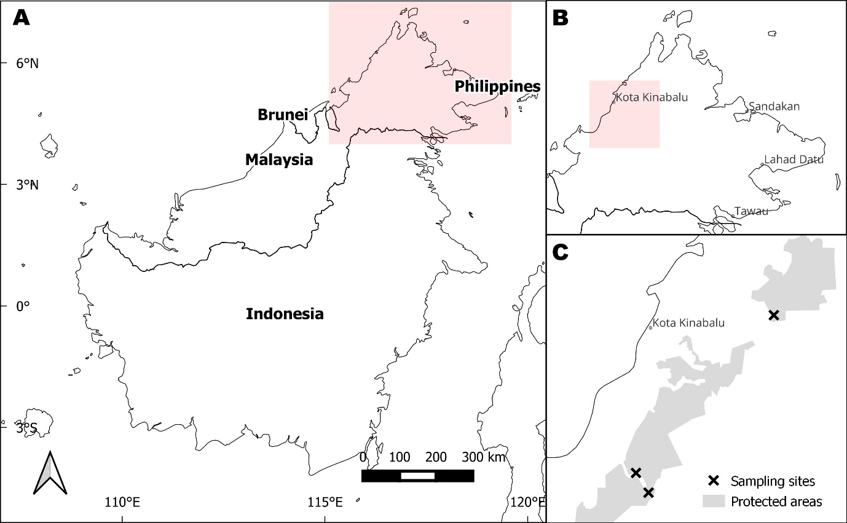
Figure 2: Sampling sites of XYZ species in Sabah, Malaysia. A. Map of Malaysia showing the location of Sabah. B. Map of Sabah showing the sampling location. C. Sampling locations within protected areas in Sabah.

Figures should be embedded in the manuscript for the initial submission. When submitting a revised article, figures should be submitted individually in JPG (.jpg) or TIFF (.tif) format, with the minimum resolution of 300 dpi. The editors reserve the right to request for unmodified or original images, and failure to provide these images could result in the rejection of a manuscript.

All references that are cited in the text must be listed in the References at the end of the manuscript. It is the responsibility of the authors to ensure that all citations in the text are listed in the References, and vice versa.

The references should be listed in alphabetical, followed by chronological order, with a hanging indent of 12.7 mm. Journal names should be given in full. The digital object identifier (DOI) should be included if available. The style and punctuation of the examples in the Reference List below should be followed accurately.

ACKNOWLEDGEMENTS

Do not include any titles of people being acknowledged.

DECLARATIONS
Research permit(s). Please include permit number and agency name. If no permits were required, please write here: Not applicable.
Ethical approval/statement. Please include information related to any ethical approval granted for this study. If none required, please write here: Not applicable.
Generative AI use. If generative AI has been used in the writing process, please write: The author(s) declare that generative AI has been used in compliance with the JTBC policies, and that I/we have reviewed and edited the content after using this tool/service and I/we take(s) full responsibility for the content of the publication. If generative AI has not been used, please write: I/we declare that generative AI was not used in this study nor in the writing of this article.

REFERENCES

Beaman JH, Edward PS (2007) Ferns of Kinabalu, an Introduction. Sabah: Natural History Publication (Borneo). 198 pp.
Chung AYC, Bosuang S, Majapun R, Nilus R (2016) Diversity and geographical ranges of insects in Crocker Range Forest Reserve, Sabah, Malaysia. Journal of Tropical Biology and Conservation 13: 135–155. https://doi.org/10.51200/jtbc.v13i.404.
Choy SC (1996) Distributional ecology of freshwater fishes in tropical rainforest streams of Borneo. In: Edwards DS, Booth WE, Choy SC (eds.). Tropical Rainforest Research — Current Issues. Monographiae Biologicae, vol 74. Dordrecht: Springer. Pp 377–386. https://doi.org/10.1007/978-94-009-1685-2_38.
Choy SC (2015) Twenty two years of inland aquatic science (1993 to 2015) and its application in Queensland: Achievements, learnings and way forward. The Proceedings of the Royal Society of Queensland 120: 23–29. http://dx.doi.org/10.5962/p.357795.
Choy SC, Chin PK (1994) Freshwater fishes from the headwaters of the Belalong-Temburong River system, Brunei Darussalam, Borneo. Raffles Bulletin of Zoology 42(4): 757–774.
Choy SC, Page TJ, De Mazancourt V, Mos B (2019a) Caridina malanda, a new species of freshwater shrimp (Crustacea: Decapoda: Atyidae) from the Wet Tropics World Heritage area, north-eastern Queensland, Australia. Zootaxa 4652(1): 113–125. https://doi.org/10.11646/zootaxa.4652.1.5.
Choy SC, Page TJ, Mos B (2019b) Taxonomic revision of the Australian species of Australatya Chace 1983 (Crustacea, Decapoda, Atyidae), and the description of a new species. Zootaxa 4711(2): 366–378. https://doi.org/10.11646/zootaxa.4711.2.8.
Esau K (1964) Structure and development of the bark in dicotyledons. In: Zimmermann MH. (ed.). The Formation of Wood in Forest Trees. New York: Academic Press. Pp. 37–50.
IUCN (2023) The IUCN Red List of Threatened Species. Version 2023-1. https://www.iucnredlist.org. (Accessed 13 March 2024).
Jeffrey S (2024) Three crucial wildlife papers for the Cabinet. Daily Express, 10 March 2024. https://www.dailyexpress.com.my/news/230314/three-crucial-wildlife-papers-for-the-cabinet/ (Accessed 13 March 2024).
Ngadan SD (2015) Local communities’ attitudes toward crocodiles and human-crocodile conflicts in Sarawak. Proceedings of the 17th Malaysian Forestry Conference, Kota Kinabalu, Sabah, Malaysia. Pp 515–523.

